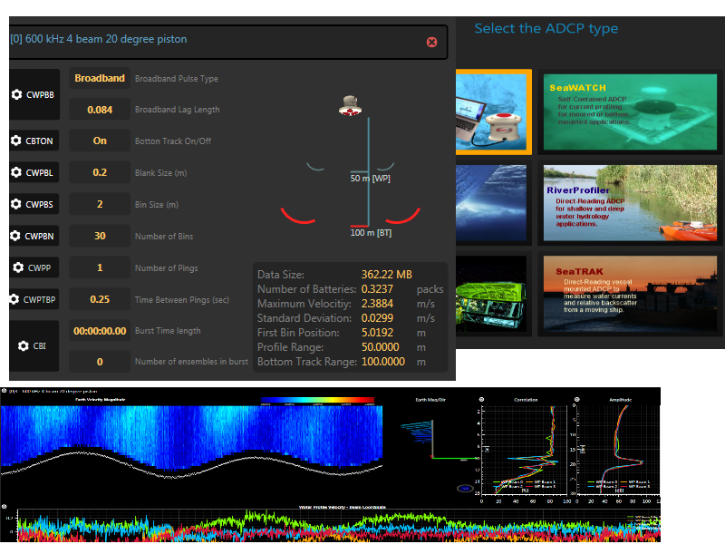

Rowe Technology, Inc.

Pulse User Guide

Pulse 4.1

Trademark Information

Rowe Technology, Inc. Pulse, the Rowe Technology, Inc. Pulse logo design, Rowe Technology, Inc. the Rowe Technology, Inc. logo design are trademark of Rowe Technology, Inc in the United States and various other countries.

All other trademarks are the property of their respective owners.

Patent Information

The accompanying product is protected by one or more U.S. and foreign patents and/or pending patent applications held by Rowe Technology, Inc.

© 2011 Rowe Technology, Inc. All rights reserved.

Rowe Technology, Inc.

12655 Danielson Court, Suite 306

Poway, CA 92064

USA

No part of this document may be reproduced or transmitted in any form or by any means, electronic or mechanical, for any purpose, without the express written permission of Rowe Technology, Inc. Under the law, reproducing includes translating into another language or format. As between the parties, Rowe Technology, Inc. retains title to, and ownership of, all proprietary rights with respect to the software contained within its products. The software is protected by United States copyright laws and international treaty provision. Therefore, you must treat the software like any other copyrighted material (e.g. a book or sound recording). Every effort has been made to ensure that the information in this manual is accurate. Rowe Technology, Inc. is not responsible for printing or clerical errors. Information in this document is subject to change without notice.

|  |  |  |  |  |
| --- | --- | --- | --- | --- |
| **Date** | **Author** | **Rev** | **App Rev** | **Comments** |
| 11/18/2011 | Rico | A | 1.05 | Initial Writing. |
| 02/01/2012 | Rico | B | 1.14 | Update to RTI ADCP User Guide Rev F. |
| 03/22/2012 | Rico | C | 2.07 | Update to 3D displays. |
| 10/31/2012 | Rico | D | 2.16 | Update with new layout. |
| 01/02/2013 | Rico | E | 2.17 | Add a SC section. |
| 08/27/2013 | Rico | F1 | 3.0 | Re-layout of Pulse. |
| 09/19/2013 | Rico | F2 | 3.1 | Updated SmartPage Environmental and Ping Control. |
| 12/11/2013 | Rico | G | 3.2 | Changed to a wizard style application. |
| 02/21/2014 | Rico | G1 | 3.2 | Added Vessel Mount options. |
| 03/17/2015 | Rico | H | 4.1 | Updated with changes from 4.1. |

About this Guide

|  |  |
| --- | --- |
|  | The Rowe Technology, Inc. Pulse User Guide is for administrators and users of the Rowe Technology, Inc. Pulse software, Acoustic Doppler and Imaging technologies.  The following related documents for the Rowe Technology, Inc. instruments are available:   * RTI ADCP DVL User Guide * Prime User Manual |

Contents

**Overview** 20

**Quick Start** 21

1. Establish Communication 21

2. View Data 22

3. Record 23

**Home Page** 25

1. Acquire Mode 26

2. Playback Mode 26

3. ADCP Utilities 26

4. Data Export 26

**Acquire Mode** 27

1. New Project 27

2. Load Project 27

Create New Project 28

1. Project Name 28

2. Project Directory 28

3. Browse Button 29

4. Serial Number Wizard 29

5. Additional Commands 29

6. Load Commands Button 29

Select ADCP Type 30

1. SeaProfiler 31

2. SeaWatch 31

3. SeaWave 31

4. RiverProfiler 31

5. SeaPilot 31

6. SeaTrak 31

Communications 32

1. ADCP Serial Comm Port 32

2. ADCP Serial Baud Rate 32

3. ADCP Set Button 32

4. Find ADCP Button 32

5. GPS Serial Comm Port 33

6. GPS Serial Baud Rate 33

7. GPS Set Button 33

Additional Communications 34

Scan ADCP 35

1. Scan ADCP Button 35

Data Storage 36

External Storage 37

Internal Storage 37

Salinity 39

1. Ocean 39

2. River 39

3. Estuary 39

4. Salinity Value 40

ADCP Time 41

1. Local Time Toggle Button 41

2. GMT Time Toggle Button 42

3. Time of First Ping Entry 42

4. Set Local Date/Time Button 42

5. Set GMT Date/Time Button 42

Time Between Ensembles 43

1. Time Between Ensembles Value 43

2. Time Value String 44

ADCP Configuration 45

1. Project Details 47

2. Ensemble Details 48

3. Prediction Model 48

4 +5. Subsystem Configuration 48

6. Scan Button 48

7. Add Subsystem Button 48

Prediction Model 49

1. Deployment Duration 49

2. Battery Type 49

3. Number of Batteries 49

4. Data Size 50

5. Total Data Usage 50

Select Frequency 51

1. Frequency List 51

Broadband Mode 52

1. Narrowband 52

2. Broadband 53

3. Narrowband Pulse-to-Pulse 53

4. Broadband Pulse-to-Pulse 53

5. Non-Coded Broadband Pulse-to-Pulse 53

6. Broadband with Ambiguity Resolver Ping 53

7. Broadband Pulse-to-Pulse with Pulse-to-Pulse Ambiguity Resolver Ping 53

8. Broadband Lag Length 53

Bottom Track On/Off 54

1. Using Bottom Track 54

2. Turn Off Bottom Track 54

Bin Commands 55

1. Blank Size 55

2. Bin Size 55

3. Number of Bins 56

Ping Commands 57

1. Number of Pings 57

2. Time Between Pings 57

Burst Mode Pings Commands 58

1. Burst Length 58

2. Ensembles per Burst 59

3. Interleave Ensembles 59

Compass Calibration 60

1. Start/Stop Calibration Button 60

2. Next Sample Button 60

3. ADCP Information 61

4. Sample 61

5. Desc 61

Zero Pressure Sensor 62

1. Zero Pressure Sensor Button 62

Deploy the ADCP 63

1. Additional Commands Button 63

2. Additional Commands Textbox 64

3. Send All Commands To ADCP Button 64

4. View Commands Button 64

Load Project 65

Projects 66

1. Refresh Project Image 66

2. Project Name 66

3. Last Modified Date 66

4. Project Time Span 66

5. Number of Ensembles 67

6. Delete Project 67

7. Project Image 67

Import 68

**View Data Graphical** 69

1. Change Sections 69

2. Ensemble Information 69

3. Subsystem Configuration Tabs 69

4. Subsystem Configuration Description 70

5. Contour Plot 70

6. Water Profile Beam Velocity Profile Plot 70

7. Correlation Plot 71

8. Amplitude Plot 71

9. Water Profile Beam Velocity TimeSeries Plot 71

10. Bottom Track Beam Velocity TimeSeries Plot 71

11. Bottom Track Range TimeSeries Plot 71

12. Playback Controls 71

Contour Plot Settings 73

1. Plot Height 73

2. Number of Ensembles 73

3. Contour Colormap 74

4. Contour Minimum Velocity 74

5. Contour Maximum Velocity 74

6. Contour Plot Type 74

7. 3D Velocity Profile 74

8. Clear Button 74

Profile Plot Settings 75

1. Filter Data 75

2. Clear Button 75

3. DataSet 75

4. Color 76

5. Beam 76

6. Max Bin 76

7. Add Button 76

8. Line Series Selection 76

9. Remove Button 76

TimeSeries Plot Settings 77

1. Filter Data 77

2. Clear Button 77

3. DataSet 77

4. Color 77

5. Beam 78

6. Max Bin 78

7. Add Button 78

8. Line Series Selection 78

9. Remove Button 78

10. Remove All Button 78

View Data Tabular 79

1. Subsystem Configuration Tab 79

2. Tabular Settings 80

3. Bottom Track Tabular Data 80

4. Tabular Data 80

View Data Tabular Settings 81

1. Subsystem Info 81

2. Set Defaults Button 81

3. Font Size 81

4. Minimum Bin 82

5. Maximum Bin 82

6. Measurement Standard 82

7. Velocity Transformation 82

View Ensemble Data 83

Ensemble Number 84

Date 84

Time 84

System Status 84

Subsystems 84

Serial Number 84

Firmware 84

Subsystem Config 84

Number of Beams 84

Number of Bins 85

Bin Size 85

Depth of 1st Bin 85

Requested Ping Count 85

Actual Ping Count 85

First Ping Time 85

Last Ping Time 85

Speed of Sound 85

Salinity 85

Water Temp 86

System Temp 86

XDCR depth 86

Pressure 86

Voltage 86

Leak Detection 86

Heading 86

Pitch 86

Roll 86

GPS fix 87

LatitudE 87

Longitude 87

Altitude 87

Speed 87

Lag 87

CPCE 87

NCE 87

RepeatN 87

Gap 87

Gain 88

Playback Controls 89

1. Record Button 89

2. Record File Size 90

3. Ensemble Decrease Move Button 90

4. Ensemble Play/Stop Button 90

5. Ensemble Increase Move Button 90

6. Playback Speed Decrease Button 90

7. Playback Speed 90

8. Playback Speed Increase Button 90

9. Display All Button 90

10. Playback Progress 90

11. Playback Index 91

12. Project Size 91

13. Loop Playback 91

13. Project Name 91

Menu 92

1. Back 92

2. Home 92

3. Playback 92

4. Projects 92

5. View Data 92

6. Screen 92

7. Average 92

8. Vessel Mount Options 93

Playback Mode 94

1. File Playback 94

2. Project Playback 94

**ADCP Utilities** 95

1. Compass Calibration 95

2. Compass Utility 95

3. Terminal 95

4. Download Data 95

5. Update Firmware 95

6. Screen Data 96

7. Vessel Mount Options 96

8. Prediction Model 96

**Screen Data Options** 97

1. Subsystem Configuration Tab 97

2. Remove Ship Speed 98

3. Remove Ship Speed - Use Bottom Track Speed 98

4. Remove Ship Speed - Use GPS Speed 98

5. Remove Ship Speed - GPS Offset 98

6. Mark Bad Below Bottom 98

7. Force 3 Beam Solution 98

8. 3 Beam Solution Bad Beam 99

9. Force Bottom Track 3 Beam Solution 99

10. Bottom Track 3 Beam Solution Bad Beam 99

11. Re-Transform Data 99

**Export Data** 100

1. MInimum Ensemble Number 101

2. Maximum Ensemble Number 101

3. Beam Velocity 101

4. Instrument Velocity 101

5. Earth Velocity 101

6. Amplitude 101

7. Correlation 101

8. Good Beam 101

9. Good Earth 101

10. Bottom Track 101

11. Earth Water Mass 101

12. Instrument Water Mass 102

13. Range Tracking 102

14. NMEA 102

15. Profile Engineering 102

16. Bottom Track Engineering 102

17. System Setup 102

18. ADCP GPS 102

19. GPS 1 102

20. CSV 102

21. Matlab 102

22. PD0 103

23. Coordinate Transform 103

**Download Data** 104

1. Populate List Button 104

2. Download Data Button 105

3. Format SD Card Button 105

4. Download Progress 105

5. Cancel Download Button 105

6. Download Directory 105

7. Overwrite Files Switch 105

8. Parse Data Switch 105

9. Select All Files Switch 105

10. Timeout Input 106

11. Download File List 106

**Update Firmware** 107

**Vessel Mount Options** 108

1. GPS 1 Serial Port 109

2. GPS 2 Serial Port 109

3. NMEA 1 Serial Port 109

4. NMEA 2 Serial Port 109

5. Heading Source 109

6. Magnetic Heading Offset 109

7. Alignment Heading Offset 109

8. Fixed Heading 109

9. Tilt Source 109

10. Pitch Offset 110

11. Roll Offset 110

12. Fixed Pitch 110

13. Fixed Roll 110

**Project File** 111

1. tblEnsemble 111

2. tblOptions 111

**Terminal View** 113

1. Communication Ports 113

2. ADCP Output 114

3. ADCP Input 114

4. Additional Commands 114

5. ADCP Buttons 115

6. GPS and NMEA Output Tabs 116

7. GPS and NMEA Serial Output 116

8. GPS and NMEA Serial Input 116

9. GPS and NMEA Buttons 116

9.1. GPS and NMEA BREAK Button 117

9.2. GPS and NMEA Clear Button 117

9.3. GPS and NMEA ESC Button 117

ADCP Communication Port 118

1. Port Option 118

2. Serial Comm Port 118

3. Scan Button 119

4. Serial Baud Rate 119

5. Ethernet Address 119

6. UDP Port 119

7. Record 119

**About View** 120

1. Pulse Version 120

2. RTI Version 120

3. Pulse Update 121

4. Licensing Information Button 121

5. End-User Rights Button 121

6. Error Log Button 121

7. Clear Error Log Button 121

8. Check Graphic Rendering Button 121

9. User Guide 122

**Validation Test View** 123

1. Start Test Button 123

2. Stop Test Button 124

3. Configure Fresh Button 124

4. Configure Salt Button 124

5. Start Pinging Button 124

6. Stop Pinging Button 124

7. Set Frequency for Tank Test 124

8. Configure Tank Button 124

9. Configure Ringing Button 124

10. Subsystem Configuration Tab 124

11. Bottom Track Range Plot 125

12. Bottom Track Speed 125

13. Bottom Track Velocity Series 125

14. Average Correlation Plot 125

15. Average Amplitude Plot 125

16. Ensemble Info 125

17. Calculate DMG Switch 126

18. Filter Data Switch 126

19. Average Data Switch 126

20. Good Ping Earth Switch 126

21. Declination Input 126

22. Clear Plot Button. 126

23. Distance Made Good Plot 126

24. Distance Made Good Values 126

25. Amplitude Average 127

26. Good Ensembles 127

27. Bad Status 127

**Advanced Compass Calibration** 128

1. User Prompt 129

2. Start/Stop Calibration Button 129

3. ADCP Info 130

4. Next Sample Button 130

5. Calibration Score 130

6. Pre-Points 130

7. Post-Points 130

8. Diff-Points 130

9. Test Results 130

10. Validate Score Switch 131

11. Mag and Acceleration Calibration Switch 131

12. Auto Sample Switch 131

13. Number of Samples Input 131

14. Calibration Stable Check 131

15. Declination 131

16. Read Compass Section 131

17. Read Compass Button 131

18. Compass Disconnect Button 132

19. Factory Magnetometer 132

20. Factory Accelerometer 132

**Compass Utilities** 133

1. Connect Button 133

2. Disconnect Button 134

3. Set Default Settings And Save Button 134

4. Mounting Ref 134

5. Taps 134

6. Polling 134

7. Sample Data 134

8. Save Cal And Config Button 134

9. Show Config 134

10. Show Params 134

11. Show Acq Param 134

12. Show Mod Info 135

13. Power 135

Compass Calibration Procedure 136

1. Magnetometer Procedure 136

2. Accelerometer Procedure 139

# **Overview**

Rowe Technology, Inc. Pulse software is used to configure, communicate and view live and recorded data from acoustic doppler and imaging instruments.

Supported **communication** to the doppler and imaging device for Pulse are serial (RS-232, RS-485 and RS-422) and Ethernet. The user will connect the instrument to their computer and Pulse will establish communication with the instrument. With communication established, the user can then configure and record data from the instrument.

Pulse will allow the user to **view and record live data** from the instrument. This is typically called working with a *Direct-Reading* instrument. Reviewing the live data will allow the user to verify communication with the instrument and allow the user to validate the data. After configuring the instrument, the user can then see in real time the changes made to verify all instrument commands are set properly. When the user is satisfied with the data from the instrument, the user can then use Pulse to record the live data. The data will be recorded to both a binary raw file and a Pulse project file. Both file types are different and have their own benefits for each user. Refer to the file format sections to get more information on the file formats.

Pulse will allow the user to **configure** an instrument. Before recording data, the user may need to modify the commands to the instrument to account for the specific environment they are in. Pulse assist the user in choosing the proper options for each command in the instrument. Pulse will help the user understand the consequences for each command change which can include loss in range, increased power consumption and increased data output size. All options can be store to the project for future reference. The options stored in the project will also allow the user to reproduce a deployment.

Pulse will allow the user to **recover data** from the instrument after a deployment. Instruments that recorded data internally are typically called *Self-Contained* instruments. When a Self-Contained instrument is recovered, the data is stored within the instrument on a SD memory card. Pulse will connect to the instrument and download the data from the instrument. The data can be download to binary and a project file.

Pulse will allow the user to **import** previously recorded data or projects. This will allow the user to view deployments from other user and also see all the options the user used with the instrument.

Pulse will allow the user to **calibrate** the instrument. The compass will need to be calibrated to the environment it is within. The pressure will need to be zeroed before being deployed. The memory card will need to be erased before a deployment. A system check will need to be done before a deployment. A maintenance record will need to be maintained for each instrument.

The application will decode the ADCP data. Also the source code to decode the data is open source on GitHub. The code is written in C#. The source code can be found at <https://github.com/rowetechinc>

# **Quick Start**

This quick start will work with Direct-Reading and Self-Contained systems. This will give a quick guide how to establish a connection to the instrument, configure the instrument, deploy the instrument and begin viewing the live data. The user can then begin recording the live data if it is a Direct-Reading system. If it is a Self-Contained system, the user will not be able to view live data unless the start time was set to current time.

## Establish Communication

|  |  |
| --- | --- |
|  | When the Pulse application is started, the application will start on the Home page. The Home page allows the user to connect to an instrument or select a Project to playback. |
|  | First thing to do is connect to the ADCP through the serial port. Communication to the ADCP is usually done with the serial port. Click on the **terminal (1)**menu button in the top right corner. This will bring the user to the terminal page. |
|  | Select the *Serial* radio button. Then select the correct **comm port (2)**. If the comm port is not shown, click the **scan button (3)***.* The comm port should then be found if port is properly configured for the user’s computer and it is not currently in use by another application. Set the correct ***b*aud rate (4)**for the ADCP. |
|  | Click the **BREAK**button to determine if the ADCP can communicate with the application. In the terminal window, you should see some data output. |

## View Data

|  |  |
| --- | --- |
|  | When the user views the data, the user can view the data *graphically* or *textually*. **Graphically** gives plots to visualize the data. |
|  | The user can also view the raw values of each plot by clicking on the **Tabular** button. |
| |  |  | | --- | --- | |  | Playback data view. | |  | Live data view | | Because a new project was created, both playback and live data can be viewed at the same time. To differentiate between **Live** and **Playback** data views, the File icon and the Ping icon are used. The File icon refers to playback data for the selected project. The Ping icon refers to live data coming from the instrument. If you do not see data, you may have the playback view selected. The [0]2 describe the type of data. |

## Record

|  |  |
| --- | --- |
|  | To begin recording, you will click the **Record** button. This button will then turn red. When data is received, the button will blink blue and the number of bytes will increase. |
|  | The **Red** button indicates that recording is turned on. The file size increasing indicates the number of bytes that have been recorded since recording started. |

# **Home Page**



## 1. Acquire Mode

This button will lead the user to a section that allows them to create or load a project. The project will store the ADCP data and any settings for the ADCP and the application.

## 2. Playback Mode

This section will allow the user to view any data either previously recorded to a project or live data from an ADCP. It will display the data tabular and graphical.

## 3. ADCP Utilities

This section contains all the utilities needed for an ADCP. This includes compass calibration, updating firmware and downloading data from the ADCP.

## 4. Data Export

This section will allow the user to export data from a selected project into many different formats.

# **Acquire Mode**

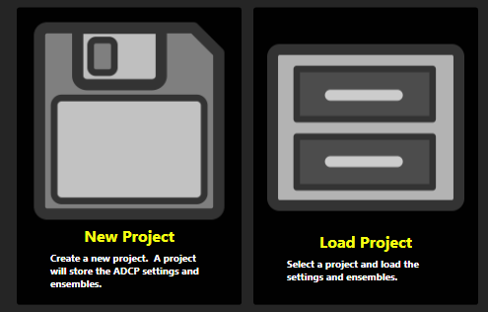

## 1. New Project

This will start the wizard to create a new project and configure the ADCP. The wizard will guide the user through setting the most important settings for an ADCP. This wizard will not set every command in the ADCP. Each step in the wizard will contain another key feature of the ADCP.

## 2. Load Project

If a project has already been created and the user just wants to load the project, they will select this section. This section will list all the projects available. The user can then choose to modify the project or playback the data from the project.

## Create New Project

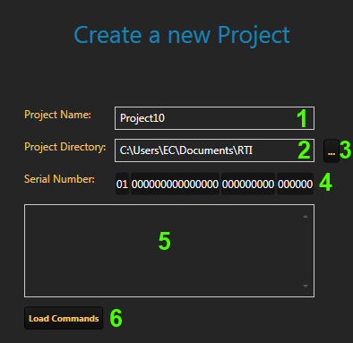

### 1. Project Name

Create a unique project name. This project name will be used to create all the files and folders for the data associated with the project.

### 2. Project Directory

Set the project directory. This will be the location where all the data for the project is stored. This includes project file and all the data recorded in the project. By default the folder path is MyDocuments/RTI.

### 3. Browse Button

This button will allow the user to browse through the computer to find the proper location where they would like the project directory to be.

### 4. Serial Number Wizard

If the serial number is known by the user, the user can enter in the serial number. If the user does not know the serial number but the ADCP is connected to the computer, the serial number can be left blank. If the ADCP is not connected to the computer, the project needs to know what type of project to create. This is done based off the serial number of the ADCP. At the very least for the serial number fields, the subsystems have to be entered in. Use the serial number wizard to add or remove subsystems to the serial number.

If the ADCP is connected to the computer, the serial number can be left blank and at a later step, the application can scan the ADCP for its serial number.

### 5. Additional Commands

If the user would like to load specific commands so they will be preset in the project, the user can enter them here. If the user at a later step, does the scan ADCP, these values may be overwritten.

### 6. Load Commands Button

This button will allow the user to browse to a file containing the ADCP commands. The commands will then be loaded into the Additional Commands text box.

## Select ADCP Type

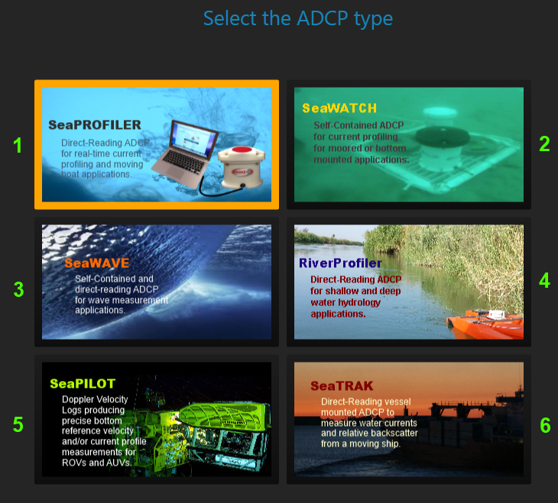

This section allows the user to set what type of ADCP they are configuring. By selecting a specific ADCP type, preset values can be set to the project. Refer to the brochure and website for the specifics of each ADCP type.

### 1. SeaProfiler

Direct-reading ADCP for real-time current profiling and moving boat applications.

### 2. SeaWatch

Self-contained ADCP for current profiling for moored or bottom mounted applications.

### 3. SeaWave

Self-contained and direct-reading ADCP for wave measurement applications.

### 4. RiverProfiler

Direct-reading ADCP for shallow and deep water hydrology applications.

### 5. SeaPilot

Doppler Velocity Logs producing precise bottom reference velocity and/or current profile measurements for ROVs and AUVs.

### 6. SeaTrak

Direct-reading vessel mounted ADCP to measure water currents and relative backscatter from a moving boat.

## Communications

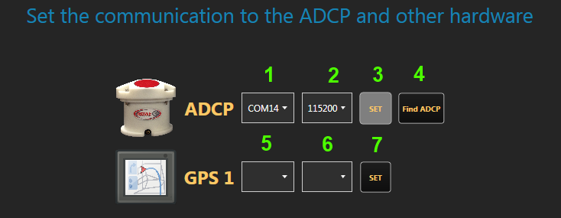

### 1. ADCP Serial Comm Port

Set the serial comm port to communicate with the ADCP.

### 2. ADCP Serial Baud Rate

Set the serial baud rate to communicate with the ADCP.

### 3. ADCP Set Button

This will turn on or off the serial port with the specific settings for the ADCP.

### 4. Find ADCP Button

This will scan all available comm ports for and ADCP. It will test all the baud rates for each comm port until it has found an ADCP or tried every combination. If an ADCP is found, the settings will be set for the comm port and baud rate.

### 5. GPS Serial Comm Port

If GPS information needs to be feed into the computer so its data can be associated with the ADCP data, this setting will allow you to set the GPS comm port.

### 6. GPS Serial Baud Rate

Set the baud rate to communicate with the GPS.

### 7. GPS Set Button

This will turn on or off the serial port with the specific settings for the GPS.

## Additional Communications

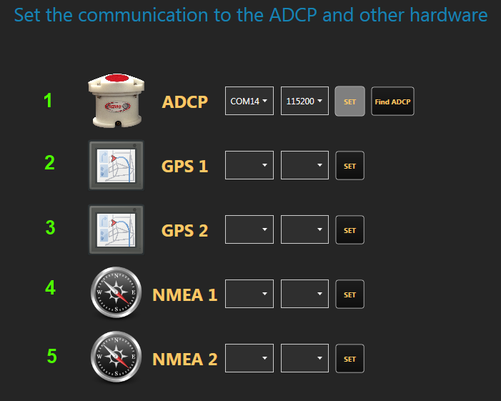

If the user selected the SeaTrak ADCP type, then additional fields will be available here to allow the user to record additional navigational instrument data to the project.

## Scan ADCP

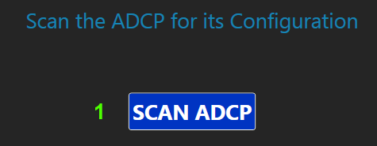

### 1. Scan ADCP Button

This button will allow the user to scan the ADCP for all the settings current set to the ADCP. These settings will then be stored in the project. The user can then modify the project with any new settings. This button allows the user to only modify the commands they would like without modifying all the settings.

## Data Storage

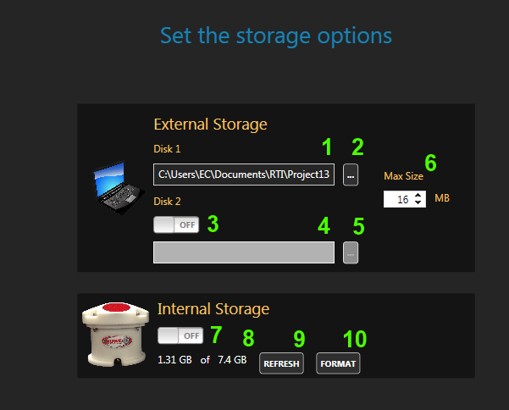

This section allows the user to set the data storage settings for internal and external storage of ADCP data.

### External Storage

External storage is recording live data from the ADCP. The data is received from the ADCP and stored locally to the computer. This storage by default is stored in two files and project file and raw file.

The project file will store the data in a SQLite database file. This will allow the user to query data later from the project file. The project file is also what Pulse uses to playback the data.

The raw file is the raw data coming from the ADCP. This data is stored to a file with the file extension ENS. There may be other files created with a SeaTrak system such as averaged data.

The user also has to option to store the data to a backup location. This is referred to as Disk 2. The backup location will contain the exact same raw data as in the Disk 1 location.

### Internal Storage

The internal storage is a micro SD card within the ADCP. This SD card is hard to access the user will need to download from the ADCP to retrieve this data. Internal storage is used when the user cannot keep a computer connected to the ADCP. This usually occurs with a Self-Contained system where it is deployed on the sea bed. Downloading the data can be done on the download page in either serial or Ethernet connection. The Ethernet connection will usually decrease the download time.

#### 1. Disk 1 External Folder Path

Folder path to the location to store the data from the ADCP. By default this is set to the project folder location.

#### 2. Disk 1 Browse Button

This will allow the user to browse to a folder path to set the Disk 1 folder path.

#### 3. Disk 2 On/Off

This will allow the user to turn on or off storing the data to a backup location. The backup location will contain the same raw data as in the Disk 1 location.

#### 4. Disk 2 External Folder Path

Folder path to the location to store the data from the ADCP. This will be the backup location of the data.

#### 5. Disk 2 Browse Button

This will allow the user to browse to a folder path to set the Disk 2 folder path.

#### 6. Max File Size

When recording the raw data from the ADCP, the user can set a maximum size for the raw data file. This will allow the files to be broken up into many smaller files. This is useful if the data has to be sent over the internet and can be sent in batches of smaller files versus one large file.

#### 7. Internal Storage On/Off

If the user would like to record data to the internal SD card in the ADCP, the user would turn this option ON. The ADCP will then begin to record any data it collects to the internal SD card. When the user does not want to record any long to the internal SD card, the user can turn it off here.

#### 8. Internal Storage Capacity

This states how much memory spaced is currently being used in the internal storage and the total capacity of the internal SD card in the ADCP.

#### 9. Refresh Button

This will refresh the Internal Storage Capacity string with the latest information. If the user feels this string is not current, the user can click the refresh button to recheck the ADCP for its memory usage and capacity.

#### 10. Format Button

This button will format the internal storage in the ADCP. By doing this the data will not be recoverable. So ensure you have already downloaded all the data from the ADCP. A warning will be given to the user.

## Salinity

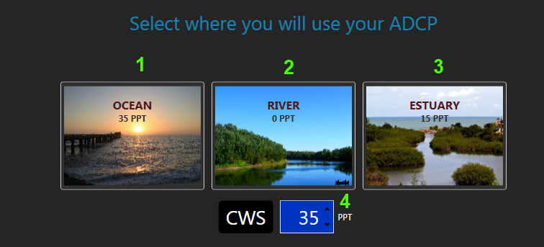

Set the salinity value for the environment of the ADCP.

### 1. Ocean

The default salinity for the ocean is 35 ppt.

### 2. River

The default salinity for the river is 0 ppt.

### 3. Estuary

The default salinity for an estuary is 15 ppt.

### 4. Salinity Value

This is the salinity value that will be sent to the ADCP. The buttons above will set this value or the user can set the value manually if they know the actual value.

## ADCP Time

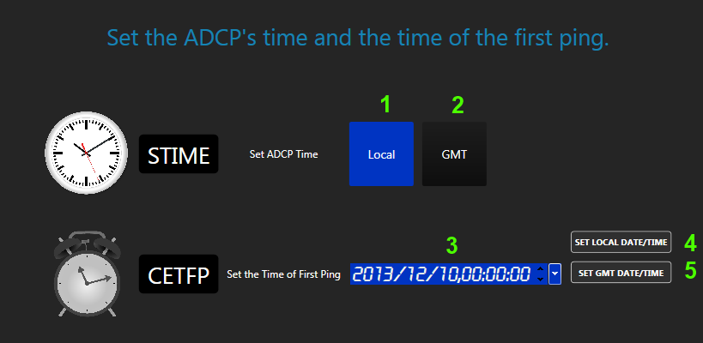

### 

This section will allow the user to set the ADCP time and the time of the first ping. The ADCP time can be set to Local or GMT. The Time of First Ping is the when the ADCP should begin collecting data. This date and time can be set to the future so batteries will not be wasted while transporting it to the location for deployment.

**WARNING:**

**A common error performed by users is to set the Time of First Ping to the future and then expect data to be output after configuring the ADCP to verify it is working. The data will not be output until it reaches that date and time set. So ensure if the ADCP is not outputting data that the Time of First Ping is not set to the future.**

### 1. Local Time Toggle Button

This toggle button will use the local time for the ADCP time. The local time is the time used on the computer that is configuring the ADCP.

### 2. GMT Time Toggle Button

This toggle button will use the GMT time for the ADCP time. The GMT time is based off the computer settings that is configuring the ADCP.

### 3. Time of First Ping Entry

Enter in the date and time that the user would like the first ping to occur. After this date and time, the data will be output and recorded based off the ADCP settings. The ADCP will be asleep before the date and time is reached saving the batteries and storage.

### 4. Set Local Date/Time Button

This will quickly set the local date and time for the Time of First Ping value.

### 5. Set GMT Date/Time Button

This will quickly set the GMT date and time for the Time of First Ping value.

## Time Between Ensembles

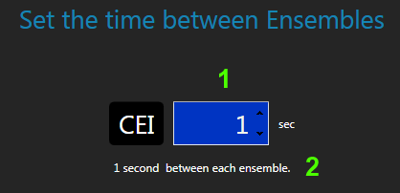

The Time Between Ensembles is how often data will be output from the ADCP. The ADCP is configured to collect data. The data will be output to the computer or recorded to the internal storage based a rate based off this value. This value is also sometimes referred to as the *Ensemble Interval*.

The ADCP will collect data and store all the information. When the data is ready to be output to a file or a computer, the data will be assembled into an ensemble and output. All data output from the ADCP in Profile mode is output in ensembles. The ensemble will contain all the information collected during the time period configured in the ADCP.

**WARNING:**

**Sometimes this value is confused with the Time Between Pings. This values has to do with how often the data is output. This value does not have anything to do with ping timing.**

### 1. Time Between Ensembles Value

This value is in seconds. It states how often data will be output to the computer or recorded to the internal storage. This value can be set seconds, minutes, hours or days.

### 2. Time Value String

This string tries to describe to the user what the value set means. It will state how often data will be output.

## ADCP Configuration

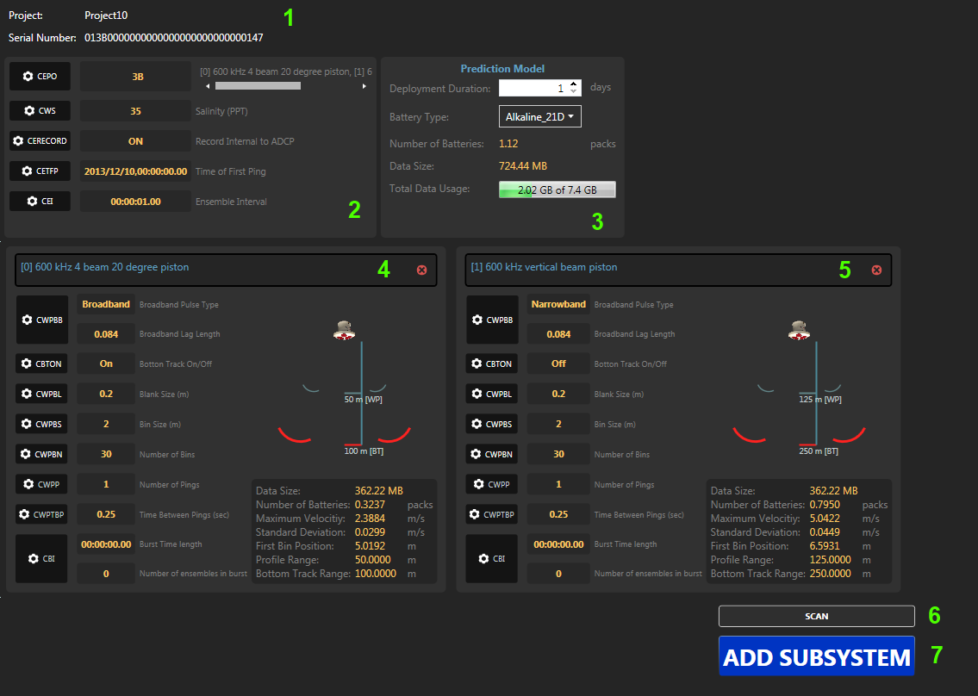

This page gives a summary of the current settings of the ADCP. They include the settings set in the previous pages and any other settings found when scanning the ADCP. This section is used to review the settings and also add new subsystems.

A subsystem is a configuration based off a frequency available on the ADCP. If the ADCP contains a single frequency system only, the user can still create multiple subsystems with each subsystem containing a different pinging configurations. This will allow the user to have one ADCP perform different task in one deployment. The user can do a profile and bottom track ping in broadband in one configuration. Then perform just a narrowband bottom track ping in another configuration.

If the user has multiple frequencies on their ADCP or a vertical beam. The user can create multiple subsystem configuration for each frequency. The limitation on which subsystem configurations that can be created based off the serial number. The serial number states what frequencies are available with your ADCP. So if the serial number was never set, then Pulse does not know which frequencies are available to configure.

By default, one subsystem configuration will be created for each frequency available. The user can add or remove any subsystem configuration. The CEPO command keeps tracks of all the subsystem configurations. It also keeps track of the order that each configuration will ping. An index value will be found for every command in CSHOW and in the titles of subsystem configurations in Pulse. This index value is based off the CEPO command.

This page will also give the prediction model on how much power and storage space will be required based off the deployment length and subsystem configurations.

*Command: CEPO*

This will list all the Subsystem Configurations and there ping order. This value represents the CEPO command. Each number represents a Subsystem Configuration and the order of the numbers is the order in which the ping will occur. For each Subsystem Configuration, there are a set of commands with their own value. When a CSHOW is given, an index value will be next to each command. The index values is the same index for the CEPO command.

In this example the serial number for the ADCP is 0146C000000000000000000000000004 and there are 3 Subsystem Configurations, this would be a dual frequency system with a vertical beam.  
4: 300 kHz 4 beam 20 degree

6: 1.2 MHz 4 beam 20 degree, 45 degree offset

C: 300 kHz vertical beam piston

The order of ping will be first the 300kHz 4 beams, then the 1.2 MHz 4 beam and then the vertical beam. Then the system will go to sleep until the next time it is scheduled to ping.

These Subsystem Configurations were created by default based off the serial number. The serial number describe the 3 Subsystem types, so it also created 3 Subsystem Configurations.

In this section, the user can now change the order of the pings for the SubsystemConfigurations and it call can add or remove SubsystemConfigurations. An example could be, the user would like a Narrowband and Broadband ping done on the 300kHz 4 beam. To do this, the user would add an additional SubsystemConfiguration of value 4 to the CEPO command. The new command would be: 46C4. If the user would like the order to also change, the user will need to delete the 6 and C first, then add the 4, 6 and C to get 446C.

When configuring the ADCP, to know if you are modifying the commands for the 4, 4, 6 or C, an index value will be next to every command when a CSHOW is displayed.



In this example, the 46C is used for the CEPO command. So for every command, you will notice a [0] n [1] n [2]. The [0] is all the command values for the 300 kHz 4 beam system. The [1] is for all the 1.2 MHZ 4 beam system. And the [2] is for all the vertical beam system. This is based off the index of the CEPO command. As you add more SubsystemConfigurations, you will also get more indexes in CSHOW and the CEPO value will change.

### 1. Project Details

This sections gives the project name and the serial number associated with the project. The serial number is important because it determines which subsystem configurations can be created. It the serial number subsystems is set to all 0’s then no configurations can be created.

### 2. Ensemble Details

These commands are common to all the subsystem configurations. These command consist of the ADCP time and environmental settings. They also give which subsystem configurations exist in the CEPO command.

### 3. Prediction Model

This area gives the prediction of a deployment. Give the number of days of the deployment and the battery type and it will predict how many batteries you will need and how much storage space you will consume.

### 4 +5. Subsystem Configuration

Sections 4 and 5 are subsystem configurations. Each configuration is specific to frequency available in the ADCP. The available frequencies are set in the serial numbers. As a subsystem configuration is created, it is added to the CEPO command. Each subsystem configuration has an index. The index is associated with the location within the CEPO command. The index is used to label each configuration in the CSHOW command. When a command is set for a subsystem configuration, the index must also be given. For example, to set the bottom track on in the subsystem configuration in section 4, the command would be: “CBTON[0] 1”. To set the bottom track on in the subsystem configuration in section 5, the command would be “CBTON[1] 1”.

A configuration can be removed by clicking the red X in the right corner. This will remove the subsystem configuration from the project. It will also modify the CEPO command. This will cause all indexes to also change.

### 6. Scan Button

The scan button will scan the ADCP for its current configurations. Any settings that were set previously to this project will be overwritten. And new configurations added will be lost.

### 7. Add Subsystem Button

This button will guide the user in creating a new subsystem configuration. The wizard will gather all the information for the subsystem configuration. Once the wizard is completed, you will be returned back to this page where you can see the prediction model change and a new subsystem configuration listed.

## Prediction Model

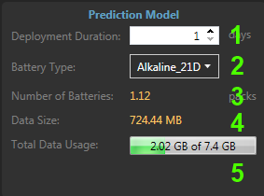

### 1. Deployment Duration

Give the number of days for the deployment. This will then be used to calculate the amount of data storage and number of batteries.

### 2. Battery Type

Select the battery type. This will determine how many batteries will be required based off the deployment settings.

### 3. Number of Batteries

This is the accumulated number of batteries required for the deployment. Each subsystem configuration will consume power. All the subsystem configurations battery consumptions will be accumulated together and the total will be displayed here.

### 4. Data Size

This is the accumulated data storage required for the deployment. Each subsystem configuration will generate data. All the subsystem configuration produced data will be accumulated together and the total will be displayed here.

### 5. Total Data Usage

This display shows based off how much space is currently available on the internal storage, it will show how much will be remaining.

## Select Frequency

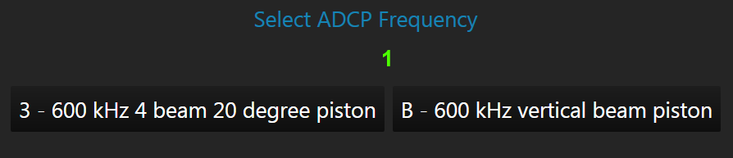

### 1. Frequency List

This will have a list of frequencies based off the serial number. These are the only subsystem configurations that can be created for the ADCP. Select which frequency you would like to create a configuration. Then click next.

## Broadband Mode

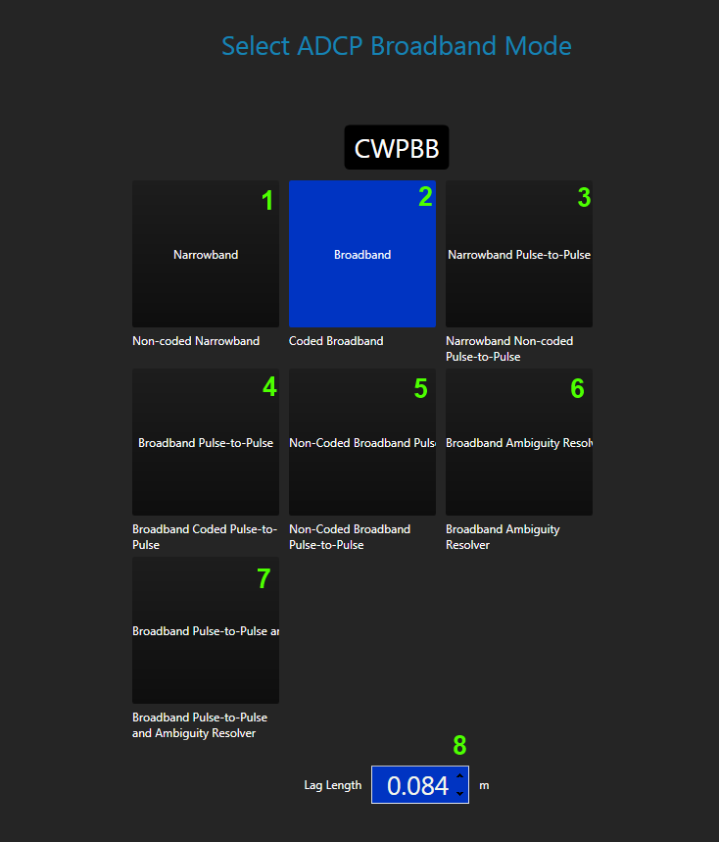

Refer the RTI ADCP DVL User Guide for more details on the broadband mode.

### 1. Narrowband

Provides long range profiles at the expense of variance. Not recommended for use with bin size less than the default bin size.

### 2. Broadband

Typically 15% less range than narrow band but has greatly reduced variance (depending on lag length). Used in conjunction with CWPBP for small bins.

### 3. Narrowband Pulse-to-Pulse

Un-coded pulse-to-pulse (no ambiguity resolver). Provides ultra-low variance for small bin sizes. Non-coded has slightly higher variance than the coded transmit without the annoying autocorrelation side peaks.

### 4. Broadband Pulse-to-Pulse

Broadband pulse-to-pulse (no ambiguity resolver). Provides ultra-low variance for small bin sizes.

### 5. Non-Coded Broadband Pulse-to-Pulse

Non-coded Broadband Pulse-to-Pulse (no ambiguity resolver). Provides ultra-low variance for small bin sizes.

### 6. Broadband with Ambiguity Resolver Ping

Broadband with ambiguity resolver ping. Used in conjunction with CWPBP averaging.

### 7. Broadband Pulse-to-Pulse with Pulse-to-Pulse Ambiguity Resolver Ping

Broadband Pulse-to-Pulse with Pulse-to-Pulse ambiguity resolver ping. Used in conjunction with CWPAP.

### 8. Broadband Lag Length

Broadband lag length. Not used with narrowband. A longer lag will have lower variance and a lower ambiguity velocity.

## Bottom Track On/Off

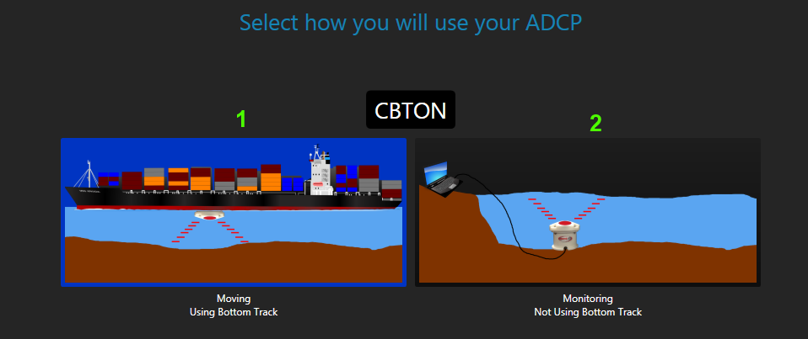

### 1. Using Bottom Track

This will turn on Bottom Track for the subsystem configuration. This will add more data for each ensemble. It will also increase the battery consumption. This will give you the depth to the bottom of the water if it is within the range of the ADCP.

### 2. Turn Off Bottom Track

This will turn off Bottom Track. This will save power and memory usage if it is known that the bottom is not within the range of the ADCP or if the bottom track information is not important.

## Bin Commands

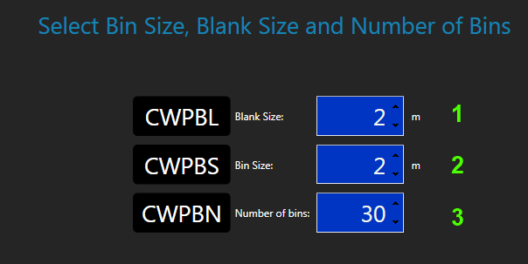

Set the commands that will control the bin size and number of bins for the subsystem configuration.

### 1. Blank Size

Sets the vertical range from the face of the transducer to the first sample of the first bin. The range is between 0 to 100 meters.

### 2. Bin Size

Sets the vertical bin size.

### 3. Number of Bins

Sets the number of bins that will be processed and output. The range is between 0 and 200 bins.

## Ping Commands

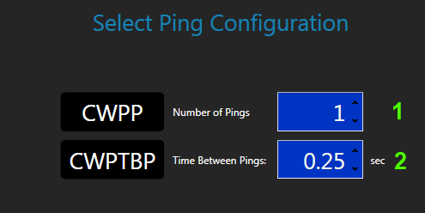

Set the commands that will control the pings for the subsystem configuration.

### 1. Number of Pings

Sets the number of pings that will be averaged together during the ensemble. The range is between 0 to 10,000 pings.

### 2. Time Between Pings

Sets the time between each ping, regardless of ping type and the next profile ping. The range is between 0.00 and 86400 seconds (24 hours).

## Burst Mode Pings Commands

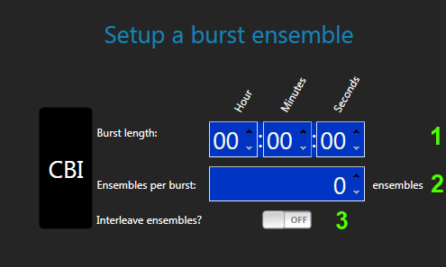

Burst mode pinging allows the timing to change from the standard way of pinging. With burst mode pinging, each subsystem configuration is given a time length to ping and wait until the next subsystem configuration begins pinging. This can be useful when strict timing for the data collection is required. With the standard mode, the pinging would occur at a fixed rate. In burst mode pinging, the data can be collect in time blocks with gaps in blocks included.

### 1. Burst Length

This is the length of time the burst should last. This works in conjunction with the ping timing. If the ping timing finishes before the burst length has completed, the ADCP will go to sleep for the remaining time and then start the next burst ping.

If you set the ping time to ping 20 times at 1 ping a second. The pinging will occur for 20 seconds. If you set the burst time length to be 1 minute, the remaining 40 seconds the ADCP will sleep.

Ensure the burst length is long enough that the pinging can complete. If the ping time was set to 20 times at 1 ping a second and set the burst length to 10 seconds. The pinging will complete after 20 second and then immediately start the next burst. The timing will not be accurate if you are using the burst timing to control external timing.

If data is stored internally during burst, one ensemble file will be created for every ensemble collected. Each file will only contain one ensemble. So many files will be created over the deployment in burst mode. The files will be with the letter B.

### 2. Ensembles per Burst

This will set the number of ensembles per a burst. Each ensemble in the burst will use the settings from the subsystem configuration. Ensure the burst length is long enough to ensure that all the ensembles can be collected within the time period.

### 3. Interleave Ensembles

Interleaving ensembles is used if you have more than one subsystem configuration. If interleaving is turned on, one ensemble from each burst will be collected. It will collect one ensemble from the first burst, then move to the next ensemble and collect one ensemble and move through all the bursts and start over. If this is turned on for one subsystem configuration, it must be turned on for every subsystem configuration.

## Compass Calibration

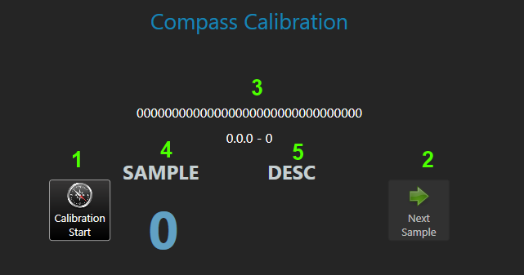

The compass calibration is required in the field to ensure the compass will not be affected by its environment. The calibration will take 12 samples. The application will then prompt when the calibration process is complete.

### 1. Start/Stop Calibration Button

This will start or stop the compass calibration process.

### 2. Next Sample Button

When the ADCP is placed in the correct orientation, press this button to take a sample. The compass will then record the information and prompt for the next orientation.

### 3. ADCP Information

When the calibration process starts, Pulse collects some information about the ADCP and displays it here. It includes the serial number and firmware version.

### 4. Sample

This will give the sample number. It will start with sample 0. It will then move through all 12 samples.

### 5. Desc

This will give the heading orientation for each sample. Some samples will require a tilt. The tilt will be given below the heading if it is required.

## Zero Pressure Sensor

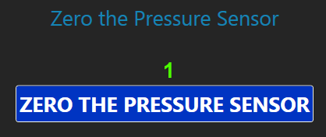

If a pressure sensor is present in the ADCP, the pressure sensor should be zeroed before being deployed. This button will zero the pressure sensor.

### 1. Zero Pressure Sensor Button

This button will zero the pressures sensor. It will send the command to the ADCP.

## Deploy the ADCP

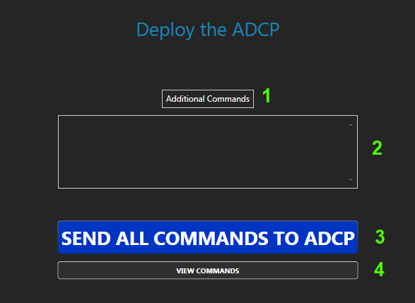

### 1. Additional Commands Button

This button will allow the user to load a file to load additional commands. The commands will be read in and put in the text box below.

### 2. Additional Commands Textbox

This textbox can be filled with additional commands. The user may want to include additional commands that may not be included in the wizard. Enter in the commands into the textbox. Make sure to include the subsystem configuration index.

### 3. Send All Commands To ADCP Button

This button will send all the commands configured in the project to the ADCP. The commands will include all the subsystem configuration commands and environmental commands.

### 4. View Commands Button

This button will allow the user to see all the commands configured within the project. A prompt will be displayed with all the commands. The user can also copy the commands from the prompt.

# Load Project

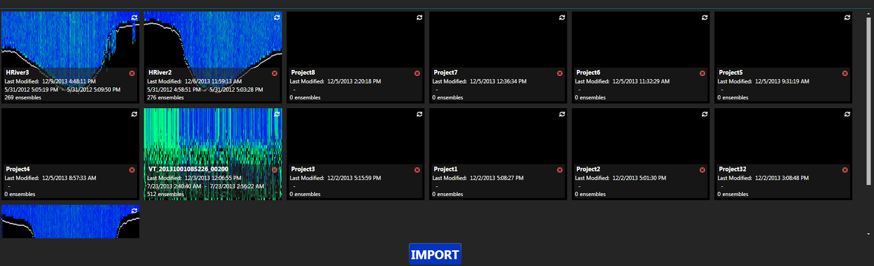

This page will display all the projects previous created. This page will allow you to select and project to playback or configure and also import data or projects.

## Projects

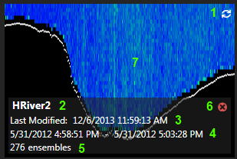

### 1. Refresh Project Image

This will refresh the project image. This is needed if you record more data to project after the project image was created. You may want to update the project image to give a better description of the new data added. This will then generate a new image in the background. When the image is updated, it will redisplay the new image.

### 2. Project Name

The project name is used to create a directory and project file. The project name is now fixed when the project is created. The project folder will be created in Documents folder. The folder will contain the project file, the binary file and any other files associated with the project such as the project image and the maintenance file.

### 3. Last Modified Date

This is the date and time the project was last modified. This is used to know which projects are most current to the user.

### 4. Project Time Span

This gives the time span of the project. It takes the first ensemble’s date and time and the last ensemble’s date and time. This will allow the user to know how long the data was recorded and at what time period.

### 5. Number of Ensembles

This will display how many ensembles are in the project.

### 6. Delete Project

To delete this project, you will click the trash can icon. This will lead to two prompts for the user.

The first prompt is a warning that the project will be deleted from Pulse. This does not mean that the data will be deleted from the computer. It just means, that Pulse will not maintain the project in the list. At any time you can re-import the project.

The second prompt will ask if you want to permanently delete the project from your computer. This will remove the folder and all data contained within the folder. If you would like to keep the project for historical reason, you would click NO here. By clicking YES, you cannot recover any of the data from this project.

### 7. Project Image

The project image gives a quick representation of what the project data looks like. This has limited screening done to data to give a clean picture. The ship speed is removed and anything below the bottom is marked bad. The white line is the sea floor and the blue is the earth velocity magnitude.

## Import



Pulse allows the user to import any data collected from ADCP. The data can be in binary or DVL format. The user can also import a previous project. The data will be decoded and stored to a new project. The user will be prompted for a project name. The user can give any unique project name. A project folder will then be created. The data imported will be then stored in the new project folder. Also the project file will be created with the imported data. The data can be played back, averaged and screened by the user.

Review the *Project File* section for more details on the project file.

# **View Data Graphical**

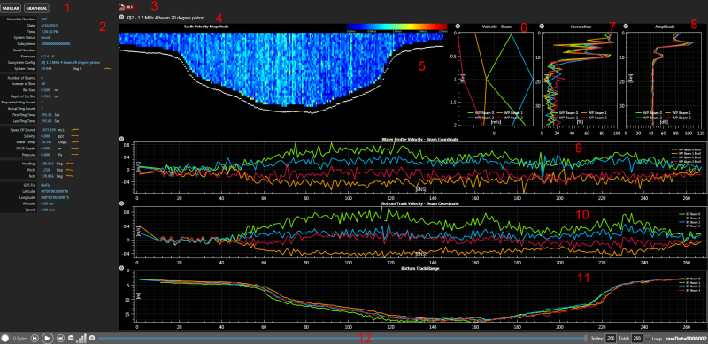

## 1. Change Sections

Change the view between Tabular and Graphical view. In the tabular view, the raw values are displayed. In the Graphical view the raw data is plotted into different plots.

## 2. Ensemble Information

This will display the basic information of the latest ensemble. This includes the serial number, number of bins and beams. The heading, pitch and roll values.

## 3. Subsystem Configuration Tabs

Each tab represents a Subsystem Configuration. A new tab will be created when a new Subsystem Configuration is found. The tabs in the ViewData pages will differ from the SmartPage tabs. These tabs include an icon. The icon represents if the data is live data or Playback data. The plots displayed are associated with the selected Subsystem Configuration tab.

|  |  |  |  |  |  |
| --- | --- | --- | --- | --- | --- |
| |  |  | | --- | --- | |  | Playback data view. | |  | Live data view | | Both playback and live data can be viewed at the same time. To differentiate between Live and Playback data views, the File icon and the Ping icon are used. The File icon refers to playback data for the selected project. The Ping icon refers to live data coming from the instrument. If you do not see data, you may have the playback view selected. The [0]2 describe the type of data. |

## 4. Subsystem Configuration Description

This give a more verbose description of the Subsystem Configuration that you are currently selected and reviewing. It will contain the CEPO index and the full description of the Subsystem. The index is also the ping order. The description is to know the ADCP frequency.

## 5. Contour Plot

The contour plot is a visual description of each bin and its velocities magnitude. It also gives the user a profile range and the contour of the bottom if it can be seen. The white line is bottom detected by the ADCP. The colors can be decode for the value by the plot legend.

This plot can also be resized by the user. Resizing the plot will cause the TimeSeries plots to also increase or decrease in size to fill the empty area. This can be useful if on small screens the TimeSeries plots are too small to be useful.

## 6. Water Profile Beam Velocity Profile Plot

This plot represents the Beam Velocity for the Water Profile data. Each bin will be displayed with its velocity value. The x-axis is the velocity of the water for each bin. The y-axis is the bin number.

This plot can also be changed to view the Water Track Beam Velocity data.

## 7. Correlation Plot

This plot represents the Water Profile Correlation data. Each bin will be displayed with its correlation value. The x-axis is the correlation value. The y-axis is the bin number.

This plot can also be changed to view the Water Track Correlation data.

## 8. Amplitude Plot

This plot represents the Water Profile Amplitude data. Each bin will be displayed with its amplitude value. The x-axis is the amplitude value. The y-axis is the bin number.

This plot can also be changed to view the Water Track Amplitude data.

## 9. Water Profile Beam Velocity TimeSeries Plot

By default this plot represents the Water Profile beam velocity data over a period of time. The x-axis represents the number of ensembles in the time series. The y-axis represents the velocity for a given bin and beam.

This plot can also be changed to view Water Profile, Water Track and Bottom Track velocities, correlation, and amplitudes. It can also display heading, pitch and roll or pressure sensor or any combination.

## 10. Bottom Track Beam Velocity TimeSeries Plot

By default this plot represents the Bottom Track beam velocity data over a period of time. The x-axis represents the number of ensembles in the time series. The y-axis represents the velocity for a given bin and beam.

This plot can also be changed to view Water Profile, Water Track and Bottom Track velocities, correlation, and amplitudes. It can also display heading, pitch and roll or pressure sensor or any combination.

## 11. Bottom Track Range TimeSeries Plot

By default this plot represents the Bottom Track Range data over a period of time. The x-axis represents the number of ensembles in the time series. The y-axis represents the range measure by Bottom Track.

This plot can also be changed to view Water Profile, Water Track and Bottom Track velocities, correlation, and amplitudes. It can also display heading, pitch and roll or pressure sensor or any combination.

## 12. Playback Controls

This section contains the playback and recording options. It allows the user to playback recorded data. It also allows the user to record the live data to a project. The playback data will come from the selected project on the HomePage.

## Contour Plot Settings

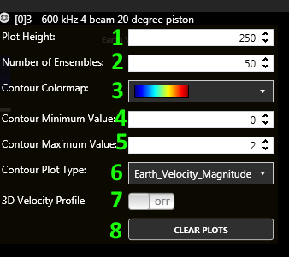

### 1. Plot Height

This value will set the height of the contour plot. By increasing the number, the contour plot will increase in size. Also the TimeSeries plots will decrease in size. This plot size allows the user to adjust both plot areas. If the TimeSeries plots are more important or too small, you can decrease the contour plot or vice versa.

### 2. Number of Ensembles

This value indicates the number of ensembles to include in ALL the plots. To see the entire plot in one picture, the user would set this value to the number of ensembles in the project. If the user would like to see only a small subsection, the user would set this value to whatever number they prefer.

### 3. Contour Colormap

This value will set the color of the contour plot. When this value changes the plot and legend will change to represent the new colormap. Different colormaps can help accentuate low or high values.

### 4. Contour Minimum Velocity

This value will set the minimum velocity for the contour plot. This value is seen in the legend as the smallest value.

### 5. Contour Maximum Velocity

This value will set the maximum velocity for the contour plot. This value is seen in the legend as the largest value.

### 6. Contour Plot Type

This value will allow the user to select the type of data to plot on the contour plot.

### 7. 3D Velocity Profile

This value will change the velocity plot between a 2D and a 3D plot.

### 8. Clear Button

This will clear all the plots include the contour plot. This will cause all the plots to have no data and wait for the next incoming data. If plots are averaging data, the accumulated data for averaging will all be cleared.

## Profile Plot Settings

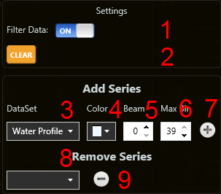

### 1. Filter Data

This input will allow the user to turn on or off filtering data. Filtering data, will cause all bad values to not be plotted. This will clean the plot so only good data is viewed in the plot.

### 2. Clear Button

This button will clear the plot of any data.

### 3. DataSet

This section will allow the user to select a new line series to plot. The DataSet is the type of data to plot. The user can choose the dataset type.

### 4. Color

This section allows the users to choose the color for the new line series.

### 5. Beam

This section will allow the user to choose the beam number for the new line series.

### 6. Max Bin

This section will allow the user to choose the maximum bin to display in the new line series.

### 7. Add Button

This button will add the new line series based off the dataset, color, beam and max bin selected.

### 8. Line Series Selection

This section will allow the user to select which line series the user wants to remove from the plot. Select the line series then click the remove button.

### 9. Remove Button

This button will remove the selected line series from the plot.

## TimeSeries Plot Settings

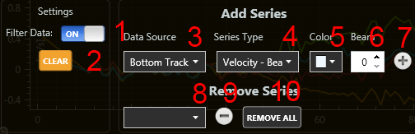

### 1. Filter Data

This input will allow the user to turn on or off filtering data. Filtering data, will cause all bad values to not be plotted. This will clean the plot so only good data is viewed in the plot.

### 2. Clear Button

This button will clear the plot of any data.

### 3. DataSet

This section will allow the user to select a new line series to plot. The DataSet is the type of data to plot. The user can choose the dataset type.

### 4. Color

This section allows the users to choose the color for the new line series.

### 5. Beam

This section will allow the user to choose the beam number for the new line series.

### 6. Max Bin

This section will allow the user to choose the maximum bin to display in the new line series.

### 7. Add Button

This button will add the new line series based off the dataset, color, beam and max bin selected.

### 8. Line Series Selection

This section will allow the user to select which line series the user wants to remove from the plot. Select the line series then click the remove button.

### 9. Remove Button

This button will remove the selected line series from the plot. If all the plots are removed, the x-axis label will be set to nothing. It will then wait until the first new line series is added to know how the set the x-axis label. This can be useful if the user wants to change the type of time series.

### 10. Remove All Button

This button will remove all the line series from the plot. This will cause the plot to not a set x-axis label. A new x-axis label will be sent when a new dataset is chosen.

# View Data Tabular

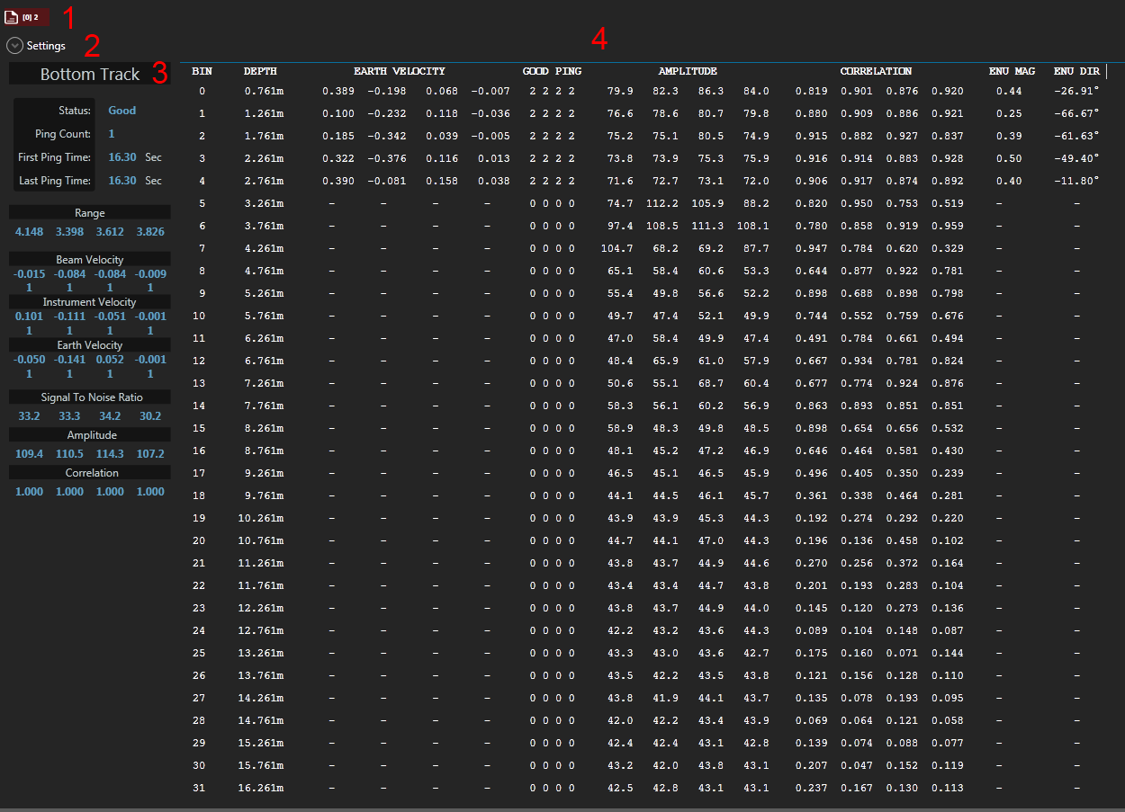

### 1. Subsystem Configuration Tab

Each tab represents a Subsystem Configuration. A new tab will be created when a new Subsystem Configuration is found. The tabs in the ViewData pages will differ from the SmartPage tabs. These tabs include an icon. The icon represents if the data is live data or Playback data. The plots displayed are associated with the selected Subsystem Configuration tab.

|  |  |  |  |  |  |
| --- | --- | --- | --- | --- | --- |
| |  |  | | --- | --- | |  | Playback data view. | |  | Live data view | | Both playback and live data can be viewed at the same time. To differentiate between **Live** and **Playback** data views, the File icon and the Ping icon are used. The File icon refers to playback data for the selected project. The Ping icon refers to live data coming from the instrument. If you do not see data, you may have the playback view selected. The [0]2 describe the type of data. |

### 2. Tabular Settings

The tabular settings allow the user to customize the view of the tabular data. This includes the font size, the measurement standards and the transformation to view.

### 3. Bottom Track Tabular Data

This column contains all the Bottom Track data. This will allow the user to see the status of Bottom Track and what the range and speed is measured by the ADCP. This will allow the user to see the raw values versus looking at the plots.

### 4. Tabular Data

This section contains all the raw tabular data. The raw values include: amplitude, correlation, velocity, magnitude and direction. The velocities can be switched between any transformations in the settings. The values can also be switched between metric or imperial. These values are updated with each new ensemble received in either live or playback.

## View Data Tabular Settings

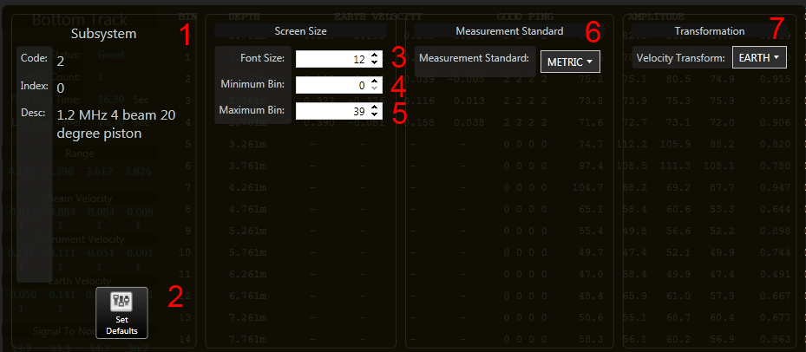

### 1. Subsystem Info

This allows the user to see more specifically what Subsystem Configuration tabular data they are looking at.

### 2. Set Defaults Button

This will reset all the settings back to their default value.

### 3. Font Size

This value will increase or decrease the font size. This can help users fit the data in the screen or enlarge the fonts to focus on specific values.

### 4. Minimum Bin

This value limits the minimum bin that will be displayed in the tabular data. This will allow the user to limit the view.

### 5. Maximum Bin

This value limits the maximum number of bins that will be displayed in the tabular data. This will allow the user to limit the view.

### 6. Measurement Standard

This option allows the user to choose between metric and imperial (standard) values.

### 7. Velocity Transformation

This option allows the user to choose which velocity transformation to display for the tabular data. Refer to the RTI ADCP DVL User Guide for more information about the different transformations.

## View Ensemble Data

This will allow the user to see the information about the ensemble. It includes the date and time and ensemble settings.

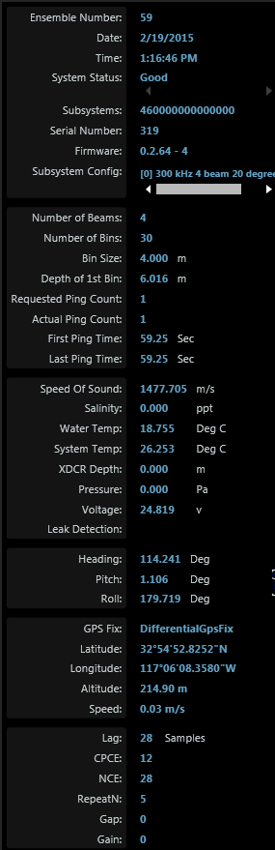

### Ensemble Number

This will give the current ensemble number. The ensemble number is increment. When the power is reset on the ADCP, the ensemble will begin again at 1.

### Date

This is the date of the ensemble.

### Time

This is the time of the ensemble.

### System Status

This will give the status of the ADCP. If there are any errors in the data or the ADCP, the status message will display the error messages.

### Subsystems

This will give all the subsystems of the ADCP. This number is taken from the serial number. A subsystem is the type of hardware the ADCP contains. Typically on a single frequency system, it will contain one character. If it is a dual frequency or a system with a 5th beam, it will contain two characters. The characters can be decoded in the ADCP and DVL User Guide.

### Serial Number

This is the serial number of the ADCP. Each ADCP will get a unique serial number.

### Firmware

This is the current firmware version of the ADCP.

### Subsystem Config

Each ensemble will contain data for a single subsystem configuration. This will display the subsystem type for the ensemble being displayed. It will also give the index of the subsystem. A subsystem can also have multiple configurations.

### Number of Beams

This will give the number of beams for the subsystem.

### Number of Bins

This will give the number of bins for the subsystem configuration.

### Bin Size

This will give the number of bins for the subsystem configuration.

### Depth of 1st Bin

This is the depth of the first bin in meters. This will include the blank. This will be the shallowest the ADCP can measure.

### Requested Ping Count

This is the number of pings the ADCP tried to measure.

### Actual Ping Count

This is the actual number of pings within the ensemble.

### First Ping Time

This is when the pinging began. This is the time since the ADCP received power.

### Last Ping Time

This when the pinging ended for the ensemble. This is the time since the ADCP received power.

### Speed of Sound

This is the calculated speed of sound based off the sensor values. This value is based off the water temperature, transducer depth and salinity.

Review the **CWSSC** command for calculating the speed of sound.

### Salinity

This is the value of the salinity. In fresh water, the value should be 0 ppt. In salt water, the value should be 35 ppt.

Use the **CWS** command to set the salinity.

### Water Temp

This is the temperature of the water. The temperature is calculated based off the sensor within the ADCP head touching the water. If the temperature sensor cannot be used, the user can set a static value using the **CWT** command.

### System Temp

This is the internal temperature of the system.

### XDCR depth

This is the depth of the transducer in the water. If the transducer is set over the edge of the boat, set the transducer depth using the **CTD** command.

### Pressure

This is the pressure value from the pressure sensor in Pascal. If no pressure sensor is installed, the value will remain 0.

### Voltage

This is the voltage of the power source into the ADCP. If it is a battery, it will give the voltage of the battery. If it is a power supply, it will give the voltage of the power supply.

### Leak Detection

If a leak detection circuit is install in the ADCP, it will give the status of the leak detection circuit.

### Heading

The heading value of the ADCP in degrees. Heading at 0 degrees will have the ADCP traveling with beam 0 forward.

### Pitch

The pitch value of the ADCP in degrees.

### Roll

The roll value of the ADCP in degrees.

### GPS fix

If a GPS is connected to the ADCP through the RS-232 connection, then this will give the GPS fix result. If the GPS is connected to a computer and setup within Pulse, then this will give the GPS fix result.

### LatitudE

The latitude value read from the GPS.

### Longitude

The longitude value read from the GPS.

### Altitude

The altitude value read from the GPS.

### Speed

The speed value read from the GPS. If bottom track cannot be used or is not available, the GPS can be used as a speed source to remove the boat speed from the water current measurements.

### Lag

The number of lag samples used in the ensemble.

### CPCE

The number of cycles per code elements used in the ensemble.

### NCE

The number of coded elements used in the ensemble.

### RepeatN

The number of code repeats used in the ensemble.

### Gap

The number of gaps used in the ensemble.

### Gain

The gain used in the ensemble.

# Playback Controls



### 1. Record Button

This button will allow the user to turn on or off recording. When recording is turned on, the button will have a red dot. When an ensemble is received to record, the red dot will turn blue indicating it is recording the data. If no dots are present, then recording has been turned off.

|  |  |
| --- | --- |
|  | Recording OFF |
|  | Recording ON |
|  | Recording ON and recording data. |

### 2. Record File Size

This value give the user feedback on the current file size for the recording. This file size does not indicate the overall project size. It will start at zero and when the record button is pressed it will begin incrementing. Once recording has stopped, this value will reset. This is mainly used to give the user positive feedback that data is recording.

### 3. Ensemble Decrease Move Button

This button allows the user to move 1 ensemble backward in the project.

### 4. Ensemble Play/Stop Button

This button allows the user to start or stop playback. When playback is on, 1 ensemble is taken from the ensemble and displayed to all views. The playback rate is set based off the playback speed which can be set by the user.

### 5. Ensemble Increase Move Button

This button allows the user to move 1 ensemble forward in the project.

### 6. Playback Speed Decrease Button

This button allows the user to decrease the playback speed.

### 7. Playback Speed

This indicator displays the current playback speed.

### 8. Playback Speed Increase Button

This button allows the user to increase the playback speed.

### 9. Display All Button

This will load all the ensembles from the project and load them to the display. If there are more than 1000 ensembles, this process could take a long time.

### 10. Playback Progress

This slider give the user feedback as to where the current ensemble is located within the project. It also allows the user to jump around in the project to different ensembles or sections.

### 11. Playback Index

This value indicates the current index within the project for the ensemble displayed. This value increment when playback is turned on. As the value is incremented, the indexed value will be taken from the project and displayed. This value cannot exceed the project size.

### 12. Project Size

This value gives the total number of ensembles recorded in the project. This will allow the user to know how many ensembles have been recorded.

### 13. Loop Playback

This options if for demonstrations. It allows the user to have a continuous loop of the playback. When the playback reaches the end of the project, it will clear the plots and start again.

### 13. Project Name

Name of the current project playing back. The ensembles will be taken from this project. The total project size is based on the project name given here.

# Menu



### 1. Back

This will go back to previous page viewed.

### 2. Home

This will take the user to the Home page. The Home page allows the user to then navigate to any section.

### 3. Playback

This will allow the user to select a file to playback. A dialog will appear to select the files to playback. It will then load the files to playback. A progress ring will be displayed while the files are being loaded. It will then change the view to the View Data page.

### 4. Projects

This will take the user to the Projects page. The Project page allows the user to create a new project or load a previous project.

### 5. View Data

This will take the user to the View Data page. The View Data page allows the user to view live data or playback previous data.

### 6. Screen

This will take the user to the Screen page. The Screen page will allow the user to screen the displayed data.

### 7. Average

This will take the user to the Average page. The Average page will allow the user to select the average options.

### 8. Vessel Mount Options

This will take the user to the Vessel Mount Options page. The Vessel Mount Options page will allow the user to set any Vessel Mount options such as a GPS or NMEA device.

# Playback Mode

Playback data previously recorded in a project. After a file or project is selected, the data can be viewed with graphs and tabular displays.

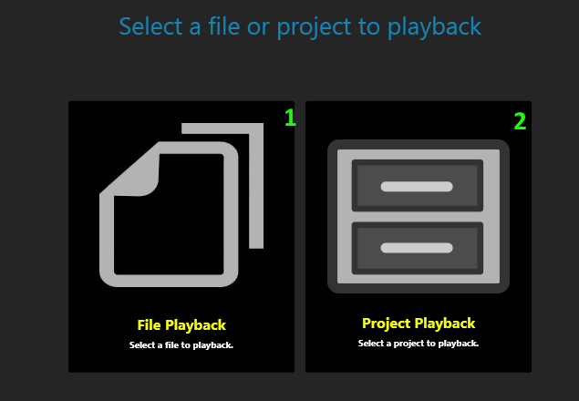

## 1. File Playback

After clicking the button, a dialog will be given to select ADCP data. The ADCP data will then be loaded and can then be played back. More than one file can be selected.

## 2. Project Playback

Click the button to go to the page to select a project to playback or import data to a project file.

# **ADCP Utilities**

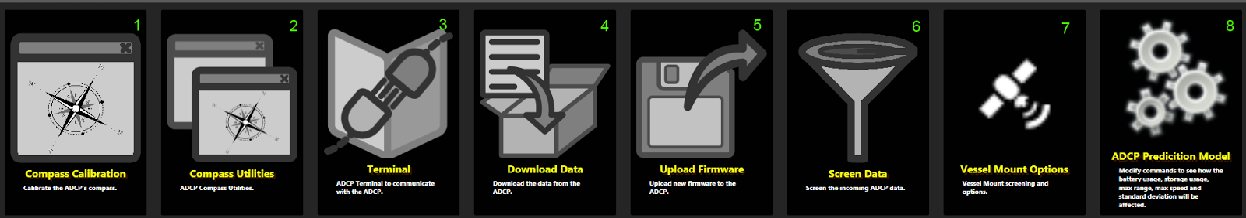

### 1. Compass Calibration

The **CompassCal** button will guide the user to the compass calibration page. This page will allow the user to perform a compass calibration. A compass calibration is required whenever the ADCP enters a new environment.

### 2. Compass Utility

The **Compass Util** button will guide the user to the compass utility page. This page will allow the user to configure the ADCP compass.

### 3. Terminal

This will bring the user to the terminal page. The terminal page will allow the user to set the terminal comm port and baud rate and communicate with the ADCP or GPS.

### 4. Download Data

The **Download** button will guide the user to the download page. The download page will allow the user to download data recorded within the ADCP on the SD memory card.

### 5. Update Firmware

The **Update** button will guide the user to update firmware page. The update firmware page will allow the user to update the firmware on the ADCP.

### 6. Screen Data

The Screen Data page will allow the user to set the screening parameters for the incoming data. The data will not be modified but when displaying the data, the data will be displayed with the screening parameters.

### 7. Vessel Mount Options

These options allow the user to determine which heading, pitch and roll to use. The user can select between using the ADCP’s HPR sensor or a GPS or GYRO devices. The user can also use a fixed value.

### 8. Prediction Model

The Prediction Model page will allow the user to set specific values such as the bin size or number of deployment days to determine power and storage consumption. This will allow the user to plan their deployments.

# **Screen Data Options**

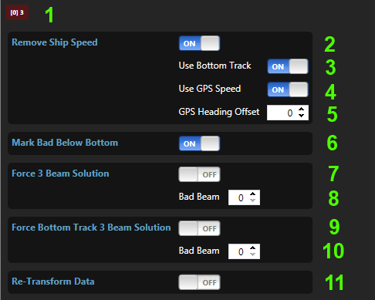

### 1. Subsystem Configuration Tab

This list all the tab panels for all the Subsystem Configurations that have been created for the ADCP. This is based off the CEPO which is set in the Hardware section. Each tab will contain the screening options for a specific Subsystem Configuration. Each panel will contain the same options but the values may differ based on the default values and the way the user configures the system.

### 2. Remove Ship Speed

This option allows the user to turn on and off removing the ship speed from the Water Profile velocity. When the ADCP data is collected, the Water Profile data will include the speed the ADCP is moving. If the ADCP is stationary, then the Water Profile data will only be the velocity of the water. But if the ADCP is moving, the Water Profile velocities will include the ADCP’s speed plus the water’s speed. To get just the water’s speed, the speed of the ADCP needs to be removed.

This section will remove the speed of the ADCP and leave just the water’s speed. The screening will not modify the data stored in the project. It will just modify the data displayed. This will allow the user to change the screening options and never effect the data stored in the project. Then the user can try different screening options.

### 3. Remove Ship Speed - Use Bottom Track Speed

This will allow the user to use the Bottom Track speed to remove the ship speed. By default this option is turned on. This value is the best value to use when removing the ship speed. But if the Bottom Track is turned off or is not valid, the user should turn this off.

### 4. Remove Ship Speed - Use GPS Speed

This will allow the user to use the GPS speed to remove the ship speed. If the Bottom Track data cannot be used, an alternative must be used to remove the ship speed. If GPS data is available, it can be used to remove the ship speed. If GPS does not exist, this should be turned off.

If both Bottom Track and GPS are turned on and both values are valid, then by default the Bottom Track data will be used over the GPS data.

### 5. Remove Ship Speed - GPS Offset

If the GPS speed is used, and it is known to have an offset from the actual speed, this value will allow the user to compensate for the GPS offset. This value will be subtracted from the GPS speed.

### 6. Mark Bad Below Bottom

By turning this option on, all velocities in Water Profile will be marked bad based off Bottom Tracks range. Using the Bottom Track Range, mark any bins below the Bottom Track range as bad. These bins exceed the depth to the bottom and should not be seen as velocity data.

### 7. Force 3 Beam Solution

This option will allow the user to force a specific beam bad. The beam is specified by the user. Then in every bin, that beam is marked bad. This is useful when a user knows that a specific beam did not collect reliable data and wants to remove the data for that beam. This can occur if a beam is obstructed.

When the beam is marked bad, it only occurs in the Beam velocity data. To make the removed beam affect the transformed data, the data must be retransformed. This is done by also turning on *Re-Transform data (11)*.

### 8. 3 Beam Solution Bad Beam

Indicate which beam you would like to mark bad.

### 9. Force Bottom Track 3 Beam Solution

This option will allow the user to force a specific beam bad in Bottom Track. The beam is specified by the user. This is useful when a user knows that specific beam did not collect reliable data and wants to remove the data for that beam. This can occur if a beam is obstructed.

When a beam is marked bad, it only occurs in the Bottom Track Beam velocity data. To make the removed beam affect the transformed data, the data must be retransformed. This is done by also turning on *Re-transform data (11).*

### 10. Bottom Track 3 Beam Solution Bad Beam

Indicate which beam in Bottom Track you would like to mark bad.

### 11. Re-Transform Data

This option allows the data to be retransformed. This is needed if the Beam velocity data is modified and user wants these changes to be passed to the transformed data. This will re-transform the data. The old Instrument and Earth velocity data will be replaced with the new transformed data.

# **Export Data**

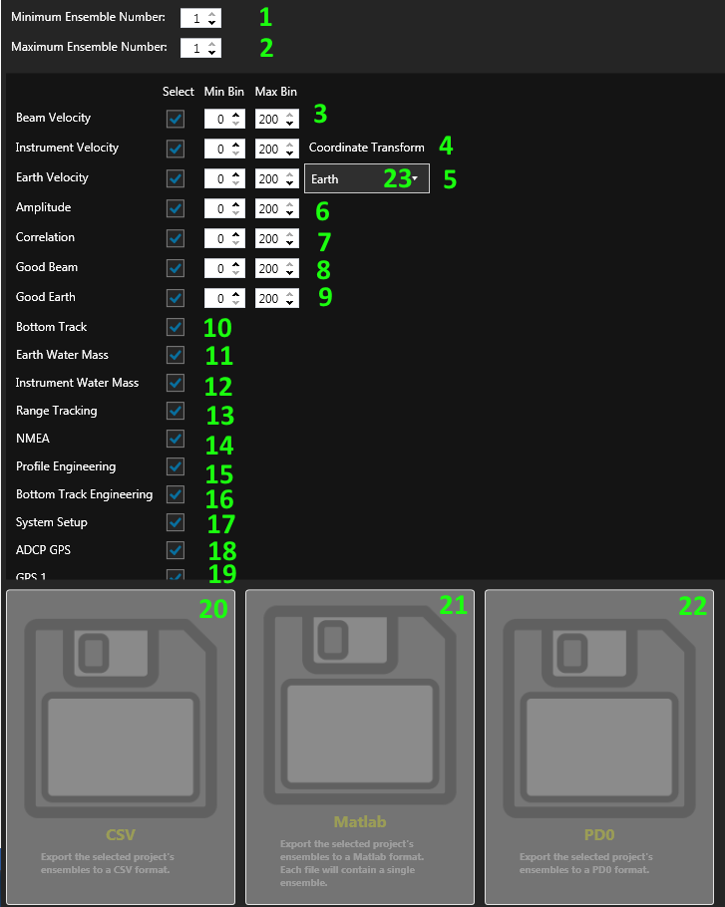

Select the data to export. Choose the format the data should be exported. For the export option to work, import the data to a project. Then choose which data to export. Then select the export data format and click the button.

## 1. MInimum Ensemble Number

The minimum ensemble number. This will be the ensemble to start the export process.

## 2. Maximum Ensemble Number

The maximum ensemble number. This will be the last ensemble in the export process.

## 3. Beam Velocity

Select if the Beam velocity data should be exported. Then select which bins within the Beam Velocity data to export.

## 4. Instrument Velocity

Select if the Instrument velocity data should be exported. Then select which bin within the Instrument Velocity data to export.

## 5. Earth Velocity

Select if the Earth velocity data should be exported. Then select which bin within the Earth Velocity data to export.

## 6. Amplitude

Select if the Amplitude data should be exported. Then select which bin within the Amplitude data to export.

## 7. Correlation

Select if the Correlation data should be exported. Then select which bin within the Correlation data to export.

## 8. Good Beam

Select if the Good Beam data should be exported. Then select which bin within the Good Beam data to export.

## 9. Good Earth

Select if the Good Earth data should be exported. Then select which bin within the Good Earth data to export.

## 10. Bottom Track

Select if the Bottom Track data should be exported.

## 11. Earth Water Mass

Select if the Earth Water Mass data should be exported.

## 12. Instrument Water Mass

Select if the Instrument Water Mass data should be exported.

## 13. Range Tracking

Select if the Range Tracking data should be exported.

## 14. NMEA

Select if the NMEA data should be exported.

## 15. Profile Engineering

Select if the Profile Engineering data should be exported.

## 16. Bottom Track Engineering

Select if the Bottom Track Engineering data should be exported.

## 17. System Setup

Select if the System Setup data should be exported.

## 18. ADCP GPS

Select if the ADCP GPS data should be exported. This data is GPS data recorded from a GPS connected to the ADCP.

## 19. GPS 1

Select if the GPS 1 data should be exported. This data is GPS data recorded from a GPS connected to the terminal GPS port.

## 20. CSV

This export option will export the data to CSV format. This is a comma delimited format. The data will include all selected options.

## 21. Matlab

This will convert all the ensembles to a MATLAB format. Each ensemble will contain its own file with all the datasets convert to MATLAB format. To convert the data to MATLAB format, the header for each dataset is removed. The data will include all selected options.

## 22. PD0

This will convert all the ensembles to a PD0 format. The data will include all selected options.

PD0 can only contain a single coordinate transform, so select which coordinate transform to export.

## 23. Coordinate Transform

If the PD0 export format is selected, select which coordinate transform data to export. PD0 can only output one velocity transform.

# **Download Data**

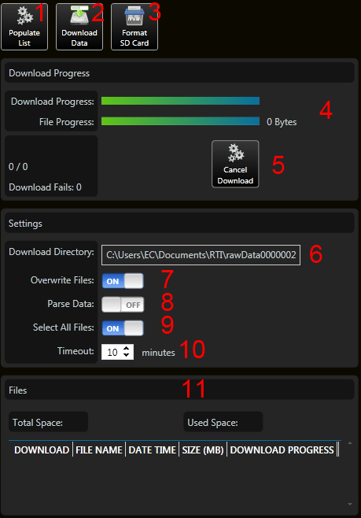

### 1. Populate List Button

This will populate the list with all the available files to download from the ADCP.

### 2. Download Data Button

This will begin the download process. This will only be available after the list is populated with the available files to download.

### 3. Format SD Card Button

Format the internal memory. This will cause all recorded data to be erased. This will also cause any additional files uploaded to the ADCP to be deleted. Only the firmware files will remain.

### 4. Download Progress

This gives the current download process. It states how many files will be download, how far into the download process a file is and how many files remain to be downloaded.

### 5. Cancel Download Button

Cancel Download process. If the download process has begun, this will allow the user to cancel to the download process.

### 6. Download Directory

Directory to download the files too. By default it will be the project folder. If the user would like to download the files to a different directory, use this settings to set the folder path. Make sure the folder chosen has the proper permissions to allow files to be added.

### 7. Overwrite Files Switch

If the files already exist in the folder path, this will determine if the file will be overwritten. If set on, the file will be overwritten. If set off, if the file name exists in the folder, the file will not be downloaded. Even if the file sizes are different, the file will not be downloaded.

### 8. Parse Data Switch

When downloading the data, the data can be parsed while being downloaded. To playback data, a project file must be created with all the ensemble data. Downloading the data by default will not create the project file. By turning this setting on, the data will be parsed and added to a project file. This will increase the download time. But after the file downloaded, the files will need to be imported to create a profile file. By turning this setting on, you eliminate the need to import the data.

### 9. Select All Files Switch

This gives a quick way to select or deselect all the files to download.

### 10. Timeout Input

This is the amount of time allotted to download a single file. If downloading a file will take longer than this, then this value will need to be adjusted. This timeout is used to ensure all the files are downloaded and if a file hangs in the download process, it will attempt to move to the next file. The timeout can be reached if the baud rate is set low or if the file is very large and could take more than the timeout time to download the entire file.

### 11. Download File List

This is the amount of time allotted to download a single file. If downloading a file will take longer than this, then this value will need to be adjusted. This timeout is used to ensure all the files are downloaded and if a file hangs in the download process, it will attempt to move to the next file. The timeout can be reached if the baud rate is set low or if the file is very large and could take more than the timeout time to download the entire file.

# **Update Firmware**

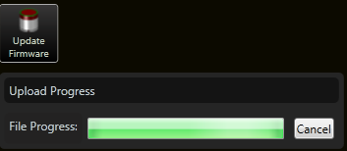

Upload the latest firmware to the ADCP. This will allow the user to upload any files including firmware to the ADCP’s internal memory. Press the “Update Firmware” button and select the file you would like to upload. Then press OK. Wait for the file to be uploaded to the ADCP.

# **Vessel Mount Options**

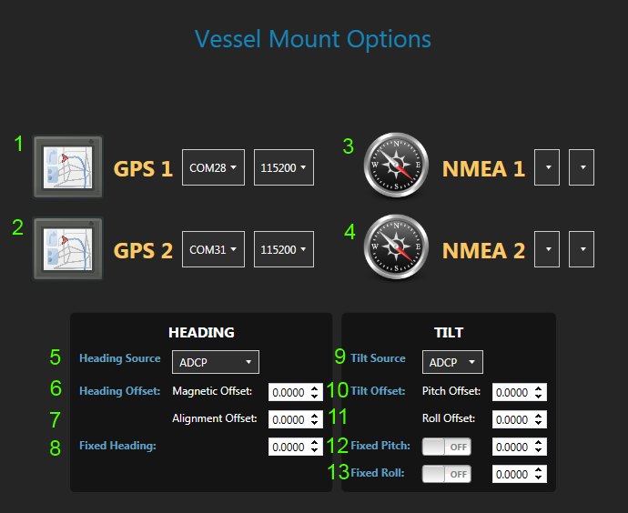

### 1. GPS 1 Serial Port

Set the serial port for the GPS 1 device. This device should give NMEA sentences so Pulse can decode and use the data.

### 2. GPS 2 Serial Port

Set the serial port for the GPS 2 device. This device should give NMEA sentences so Pulse can decode and use the data.

### 3. NMEA 1 Serial Port

Set the serial port for the NMEA 1 device. This device should give NMEA sentences so Pulse can decode and use the data.

### 4. NMEA 2 Serial Port

Set the serial port for the NMEA 2 device. This device should give NMEA sentences so Pulse can decode and use the data.

### 5. Heading Source

Set the source for the heading. This will determine where the heading should come from. Either the ADCP’s heading, NMEA heading from the HDT sentence or a fixed heading.

### 6. Magnetic Heading Offset

Give an offset value for the magnetic declination of the environment. This value will be added to the heading value.

### 7. Alignment Heading Offset

Give an offset value for the alignment error. This value is used to correct for any alignment error when alignment the ADCP with ship. This value will be added to the heading value.

### 8. Fixed Heading

If the Fixed Heading source is selected, this heading value will be used for the heading. The offsets will also be added to this value.

### 9. Tilt Source

Set the source for the tilt values. This will determine where the tilt values should come from. Either the ADCP’s tilt, NMEA tilt from a GYRO or a fixed pitch and roll.

### 10. Pitch Offset

Give an offset value for the alignment error of the pitch value. The value will be added to the pitch value.

### 11. Roll Offset

Give an offset value for the alignment error for the roll value. The value will be added to the roll value.

### 12. Fixed Pitch

Turn on or off the fixed pitch. When fixed pitch is turned on, a fixed pitch value will be used. This will overwrite any pitch value. The offset will also be added to the fixed value.

### 13. Fixed Roll

Turn on or off the fixed roll. When fixed roll is turned on, a fixed roll value will be used. This will overwrite any roll value. The offset will also be added to the fixed value.

# **Project File**

The project file is a SQLite database file. There are 2 tables located in the database file. One tables represent information recorded by the ADCP. The other table is for settings for the ADCP and applications. This will allow a user to send and receive a SQLite file and also see the settings used in the ADCP and application.

There are many applications to view a SQLite database file. SQLite can be decoded in many popular programming languages, so the user then has access to the data in a uniform file format.

A popular SQLite file viewer can be found here:

<http://sqliteadmin.orbmu2k.de/>

The schema of the SQLite cannot be guaranteed to be stay the same between different versions of Pulse. If the schema does change, it is possible that previous SQLite files will not be read properly by Pulse. If schema does change and Pulse cannot read the database file, then importing the binary data will generate a new database file. But the ADCP settings will be lost. In the future, a converter may be created to convert old project files to the latest version.

Because the project file is a database, the project file can also be queried for specific data at certain date and times. This will allow for quicker and easier exporting of the data.

### 1. tblEnsemble

This table in the project file contains all the ensemble data. Each row in the table is an ensemble. Each column in a row is a dataset. The datasets are stored in JSON format. This allows the data to be human readable. This does increase the file size, but the binary file will always be available if the user wants a reduced file size.

Also by make the data in JSON format, in the future the data can be transferred over the internet easier because JSON is a popular format for web information to be transported.

### 2. tblOptions

This table will contain the ADCP settings, application settings and revision.

The AdcpConfiguration column will contain the configuration of the ADCP. The Pulse software when retrieve the ADCP configuration and store it in the project file when the SmartPage is loaded. This is helpful for troubleshooting and reproducing an ADCP configuration.

The AppConfiguration can be used by any application to save the application settings. If used with Pulse, the application settings will be stored here. This allows Pulse to know how the user wants the application setup for the user. This will include screening options and display options.

The revision is the revision of the project file. As the Project file evolves, this revision will be incremented to know which version the file is so if it needs to be converted, it will know how.

# **Terminal View**

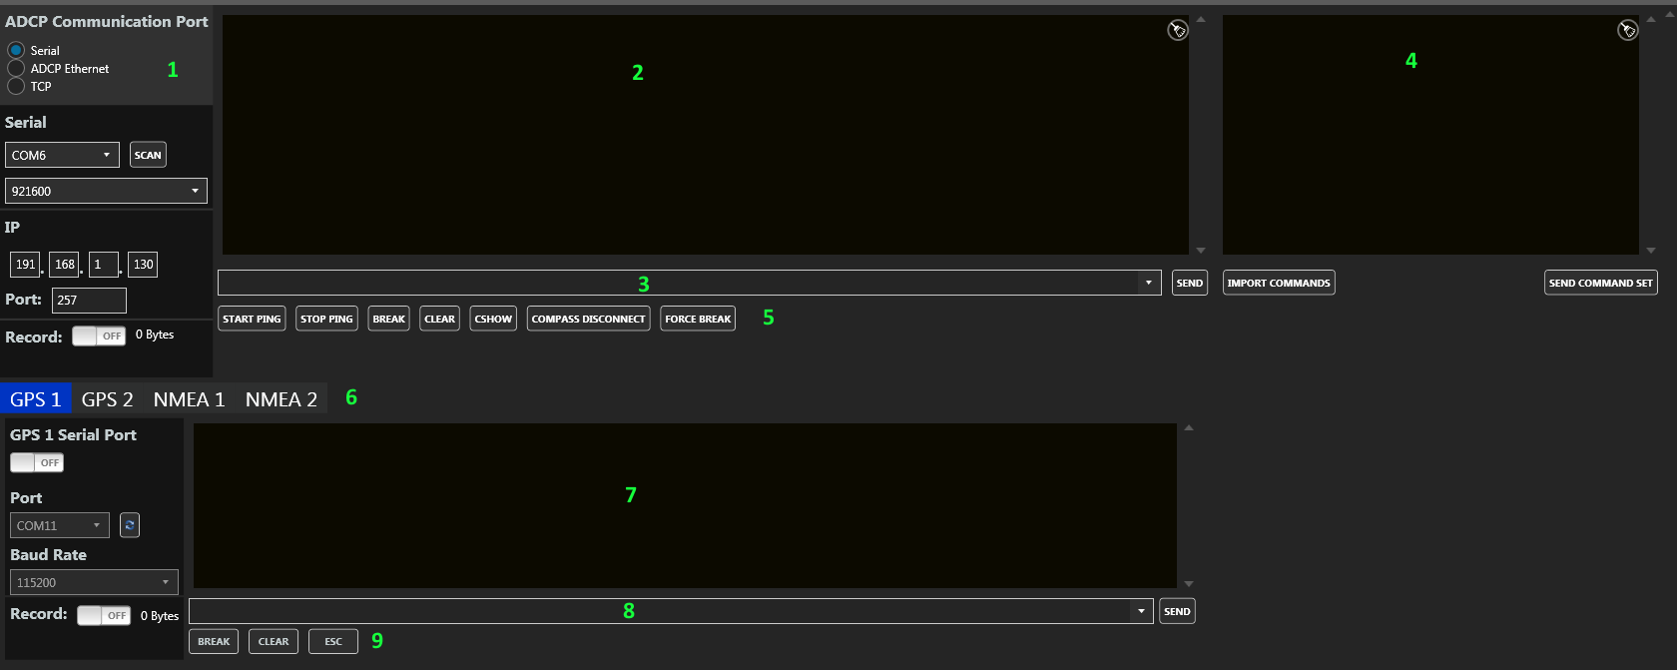

The terminal allow the user to communicate with the ADCP through a serial or Ethernet connection. This can be used to send command and see data output.

### 1. Communication Ports

This will allow the user to select between using the Ethernet or serial port to communicate with the ADCP.

**SERIAL –** Underwater cable using the RS-232 or RS-485 serial connection.

**ADCP ETHERNET –** Underwater cable using the RJ-45 Ethernet connection. Communication will be done through UDP.

**TCP –** Connect the underwater cable serial connection to a Serial-To-Ethernet adapter. Communication will be done through TCP/IP.

The Ethernet pinging is done different from serial communication.  You must poll the ADCP for data.  A buffer within the ADCP is filled, when the ADCP is pinged through the Ethernet, it will dump whatever is in the buffer.

The ADCP does not contain a TCP/IP server. So to use Ethernet connection, UDP must be used. When using UDP, the ping command will be sent. The ping command uses the "Internet Control Message Protocol (ICMP)". Within the ping command is a buffer. This buffer is used to store the command.  The ping command will cause the ADCP to send a ping response and within the ping response is a buffer which contains the ADCP data.

Any command sent through the Ethernet must start with "RTIy".



The command must end with a carriage return (\r).

Example if you want to send a BREAK.



To poll the ADCP for data you send a blank command.



If you are writing your code in C#, you can find examples of this in the file:  
<https://github.com/rowetechinc/RTI/blob/master/Communications/AdcpEthernet.cs>

CSHOW will give the IP address of the ADCP.

### 2. ADCP Output

As data is received, you will see characters displayed in the terminal. The characters are not human readable unless the ADCP is set to DVL, ASCII or a special mode.

### 3. ADCP Input

This textbox allows the user to enter in a command to send to the ADCP. The textbox will remember passed commands. Once the command is entered into the textbox, press the send button to send it to the ADCP.

### 4. Additional Commands

This will allow the user to load a file of additional commands. It will also allow the user to reuse a set of commands. Enter in all the commands into the box. Then click “Send Command Set” button.

Press the “Import Commands” button to load a file with commands. The commands within the file will be loaded into the text box. Edit any of the commands. Then press the “Send Command Set” button.

### 5. ADCP Buttons

These buttons are common commands sent to the ADCP. They include starting and stopping pinging, sending a BREAK and a CSHOW.



#### 5.1. Start Ping

Start the pinging process. This will set the Time then start pinging.



#### 5.2. Stop Ping

Stop the pinging process. This will send a BREAK then stop pinging.



#### 5.3. BREAK

This button will send a BREAK to the ADCP. The BREAK is used to wakeup the ADCP. The ADCP will output a banner message when the BREAK is received.

First a hard BREAK is sent to the ADCP. A hard BREAK is a hardware BREAK. If no banner is received from the ADCP, a soft BREAK is sent to the ADCP. A soft BREAK is a software BREAK where the command BREAK is sent. If neither of these command wakeup the ADCP, then most likely there is an issue with the connection to the ADCP.



#### 5.4. CLEAR

Clear the terminal of any text.

#### 5.5. CSHOW

Send the CSHOW command. This will display all the commands that are set in the ADCP.



#### 5.6. COmpass Disconnect

The ADCP can be put into Compass pass through. This allows the user to communicate and configure the ADCP’s internal compass. When in compass pass through, any commands received from the ADCP will go directly to the ADCP. To get out of this mode, press this button. This will send the command to disconnect.

This button will send the command to disconnect the ADCP from compass mode. If the user is trying to talk with the internal compass, the user must go into compass mode. If the user does not properly exit out of compass mode, the ADCP will remain in compass mode. In compass mode, the ADCP will not function properly. This button will allow the user to exit out of compass mode if the ADCP was accidently left in compass mode.



#### 5.7. Force BREAK

Send a Force BREAK. This will send a 20 second hard BREAK. It will then set all the baud rates in the ADCP to 115200. This command is used if communication cannot be made with the ADCP. This will force the ADCP to be in a specific mode.

### 6. GPS and NMEA Output Tabs

There are currently 4 tabs to choose from. Each tab refers to a different serial port for GPS and NMEA data. The user can set each of the 4 serial port to receive data from external devices. If the data is in NMEA format, the data will be added to the ensemble. The data will also be added to the project file. Each tab’s data can also be used for screening.

### 7. GPS and NMEA Serial Output

When the GPS is connected to the serial port, this will display all the output from the GPS. As data is received, you will see characters displayed in the terminal.

### 8. GPS and NMEA Serial Input

This textbox allows the user to enter in a command to send to the GPS. The textbox will remember passed commands. Once the command is entered into the textbox, press the send button to send it to the GPS.

### 9. GPS and NMEA Buttons

These are common buttons used to communicate with the GPS.

### 9.1. GPS and NMEA BREAK Button

This button will send a BREAK to the GPS.

### 9.2. GPS and NMEA Clear Button

This button will clear the GPS serial output display.

### 9.3. GPS and NMEA ESC Button

This button will send an ESC character to the GPS.

## ADCP Communication Port

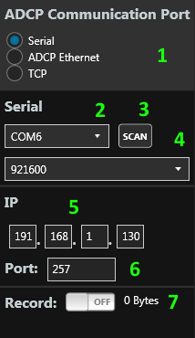

### 1. Port Option

Select between using the ADCP Ethernet, TCP or serial port to communicate with the ADCP.

**SERIAL –** Underwater cable using the RS-232 or RS-485 serial connection.

**ADCP ETHERNET –** Underwater cable using the RJ-45 Ethernet connection. Communication will be done through UDP.

**TCP –** Connect the underwater cable serial connection to a Serial-To-Ethernet adapter. Communication will be done through TCP/IP.

### 2. Serial Comm Port

Set the serial port comm port.

### 3. Scan Button

This button will scan for any available comm ports on the user’s computer.

### 4. Serial Baud Rate

Set the serial baud rate.

### 5. Ethernet Address

Set the Ethernet address of the ADCP. The Ethernet must be turned on the ADCP for the Ethernet connection to work. Refer to the RTI ADCP DVL User Guide on how to enable the Ethernet port.

Also make sure the user’s computer matches the address range as the ADCP. If they do not match, either change the ADCP’s Ethernet address or change the user’s computer. For the addresses to be in the same range, the first 2 values should be the same on both the ADCP and computer.

### 6. UDP Port

Set the UDP port. This is used for the Ethernet connection.

### 7. Record

Record the raw data from the ADCP. This will record any data that passes through terminal.

# **About View**

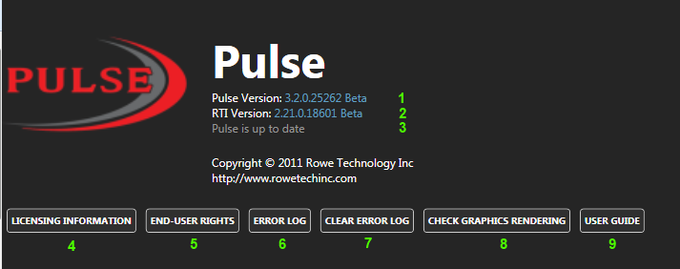

### 1. Pulse Version

This section list the Pulse version.

### 2. RTI Version

This section list the version of RTI source code used for this application. The RTI source is code is open source and freely available on the internet at: <https://github.com/rowetechinc> . This source code contains all the functionality of the ADCP. It is written in C#. If the user would like to write through own application to work with the ADCP, this source will get them started with all the commands and decoding of the data.

### 3. Pulse Update

This section will display if Pulse is up to date. An internet connection is required for this check. If a new version is available, a dialog box will appear asking if the user would like to update. It will then display in the About view if an update is available.

### 4. Licensing Information Button

This will display all the credits for other source code and art used in Pulse. The user can scroll through the information to find information about all the projects used.

### 5. End-User Rights Button

This will display the end-user rights and copyright information for the Pulse software.

### 6. Error Log Button

This button will display all the information in the error log. The user can then scroll through the data to see if they can determine any issues. This is helpful when issues involve file permissions.

### 7. Clear Error Log Button

This button will clear all the data in the error log.

### 8. Check Graphic Rendering Button

If the application is running slow, it may be because the application is rendering in software mode. This is when the CPU is used and not the GPU to process the graphics. This will cause the application to run slow. There are many reasons why the application may be run in software rendering. This will not go over why, but if it is running in software rendering. It checks a couple different places on your computer to determine which mode it is running in. Most of the time, if the settings are in software rendering mode, then a better graphics card is required to run the application.

#### 8.1 Render Tier

This is internal to WPF applications to check if the application is currently running in Hardware or Software rendering mode. If the value is less than 2, then the application is running in software rendering and will cause the application to run slow.

#### 8.2 ProcessRenderMode

This is internal to WPF applications to check if the application is currently running is Hardware or Software rendering mode. If the value states “SoftwareOnly” then the application is running in software rendering and will cause the application to run slow.

#### 8.3 Registry Hwdr Disable

This checks *HKEY_CURRENT_USER\Software\Microsoft\Avalon.Graphics\DisableHWAcceleration* in the registry to determine if hardware rendering is turned on or off. If the value is greater than 0, then hardware rendering is disabled and will cause the application to run slow. Other applications may turn this off, so it is unclear why this is not enabled if it turned off.

### 9. User Guide

Load the Pulse user guide.

# **Validation Test View**

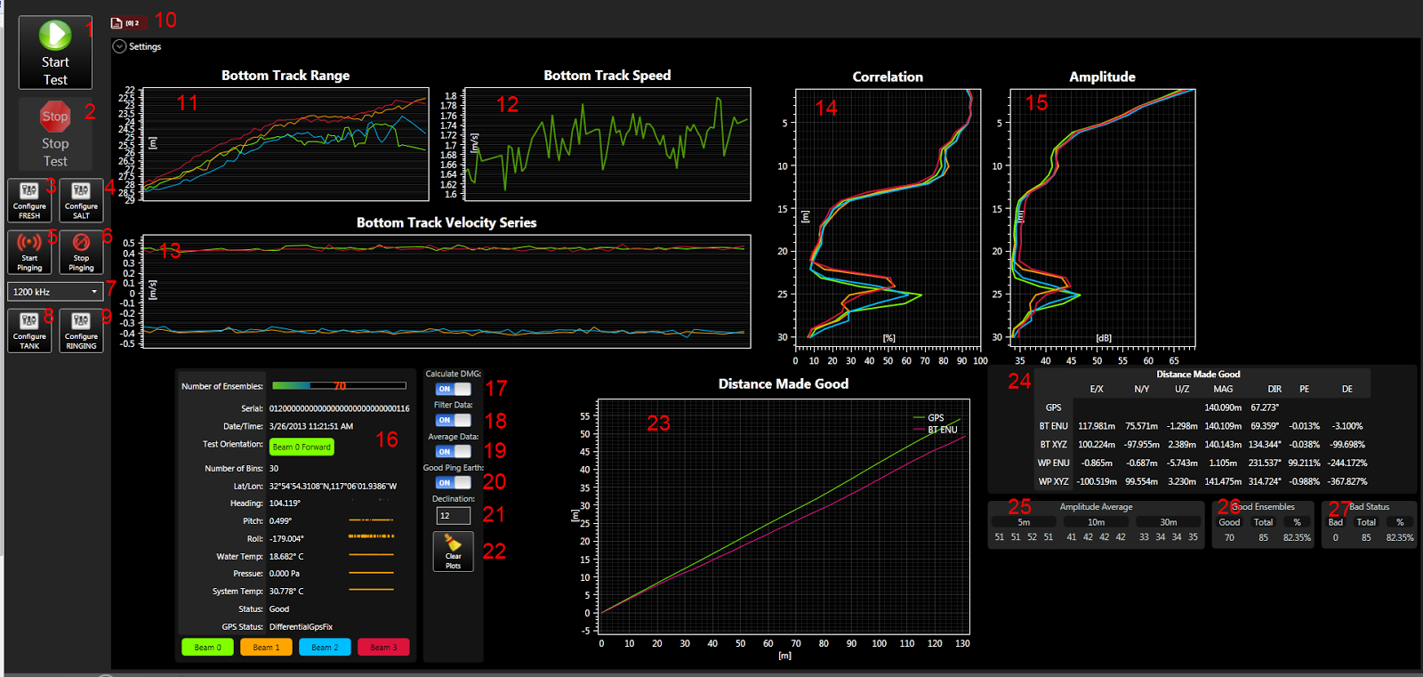

This view is used for internal testing to verify the ADCP is working. This test requires a GPS. The basic test is to drive a straight line and verify the distance traveled between the ADCP and the GPS is the same. It also gives an average Correlation and Amplitude plot to see if any plots stand out. It also verify that Bottom Track is working.

To run the test, start driving a straight line and click the start test. Begin collecting data. After 250 ensembles, click the Stop Test button and check the distance made good values to see how far off they are from each other. The GPS is considered the reference unit. The PE values I the percentage error. The lower the percentage the better.

### 1. Start Test Button

This button will start recording any data that comes from the ADCP connection. The data will be stored to C:\RTI_Capture. This will also start collecting data to calculate a distance made good and average values.

### 2. Stop Test Button

This button will stop recording the data and stop collecting the data.

### 3. Configure Fresh Button

This button will configure the ADCP for a fresh water test. This includes setting the RS-232 baud rate to 19200 for the GPS, setting the salinity to 0 and start pinging.

### 4. Configure Salt Button

This button will configure the ADCP for a salt water test. This includes setting the RS-232 baud rate to 19200 for the GPS, setting the salinity to 35 and start pinging.

### 5. Start Pinging Button

This button will send a command to the ADCP to start pinging. It will also set the time to the ADCP.

### 6. Stop Pinging Button

This button will send a command to the ADCP to stop pinging.

### 7. Set Frequency for Tank Test

Set the frequency for tank testing. A different command set is sent based off the frequency for tank testing.

### 8. Configure Tank Button

This button will send a set of commands based off the frequency for the tank test.

### 9. Configure Ringing Button

This button will send a set of commands based off the frequency for a ringing test.

### 10. Subsystem Configuration Tab

Each tab represents a Subsystem Configuration. A new tab will be created when a new Subsystem Configuration is found. The tabs in the Validation Test pages will differ from the SmartPage tabs. These tabs include an icon. The icon represents if the data is Live or Playback data. The plots displayed are associated with the selected Subsystem Configuration tab.

|  |  |  |  |  |  |
| --- | --- | --- | --- | --- | --- |
| |  |  | | --- | --- | |  | Playback data view. | |  | Live data view | | Both playback and live data can be viewed at the same time. To differentiate between **Live** and **Playback** data views, the File icon and the Ping icon are used. The File icon refers to playback data for the selected project. The Ping icon refers to live data coming from the instrument. If you do not see data, you may have the playback view selected. The [0]2 describe the type of data. |

### 11. Bottom Track Range Plot

This plot will display the Bottom Track range. This will show how the bottom looks.

### 12. Bottom Track Speed

This plot will display the Bottom Track Speed. This will show the speed of the boat if moving.

### 13. Bottom Track Velocity Series

This plot will display the Bottom Track Velocities. This plot will allow the user to see the orientation of the ADCP. Based off which beams are showing positive and negative values, you can tell what the orientation of the ADCP.

### 14. Average Correlation Plot

This plot will show the average correlation values. This plot will help to see if any beams are weak.

### 15. Average Amplitude Plot

This plot will show the average amplitude values. This plot will help to see if any beams are weak.

### 16. Ensemble Info

This section displays the ensemble information. This includes the ensemble number and date and time. It includes the heading, pitch and roll. It also displays the GPS data if any is being received.

### 17. Calculate DMG Switch

This switch will turn on and off calculating distance made good information with the incoming data.

### 18. Filter Data Switch

This switch will turn on and off display bad values in the plots. By turning off, the plot can look noisy. By turning it on you can see gaps when no good data exist.

### 19. Average Data Switch

This switch will turn on and off displaying averaged data in the Amplitude and Correlation plot.

### 20. Good Ping Earth Switch

N/A

### 21. Declination Input

This input will allow the user to enter in the declination value for the compass.

### 22. Clear Plot Button.

This button will clear all the plots and clear all the accumulated data for the averages. It will also clear all the distance made good data.

### 23. Distance Made Good Plot

This plot will show the path as seen by the ADCP and the GPS. The two lines should be close to each other. If the GPS is not orientated in the same direction, the plots may not travel the same path, but the lengths of each line should be close to each other.

### 24. Distance Made Good Values

This section displays the accumulating distance made good calculations. This GPS distance is calculated by taking the distance from the first point when the Start Test button was clicked and the current point. It is important that the boat travels a straight path because the GPS calculation assumes a straight path since there is always only 2 points in the calculation of distances.

The Bottom Track and Water Profile distance is and direction is calculated based off the time between each ping and speed measured by the ADCP’s Bottom Track and Water Profile data. The 2nd bin is used in the Water Profile velocity data.

The main value to look at it the PE value. The lower the value the better. The PE is the percentage error.

### 25. Amplitude Average

This section displays the average amplitude at different depths.

### 26. Good Ensembles

This displays how many ensembles in the test were good.

### 27. Bad Status

This displays how many ensembles in the test contained a bad STATUS value.

# **Advanced Compass Calibration**

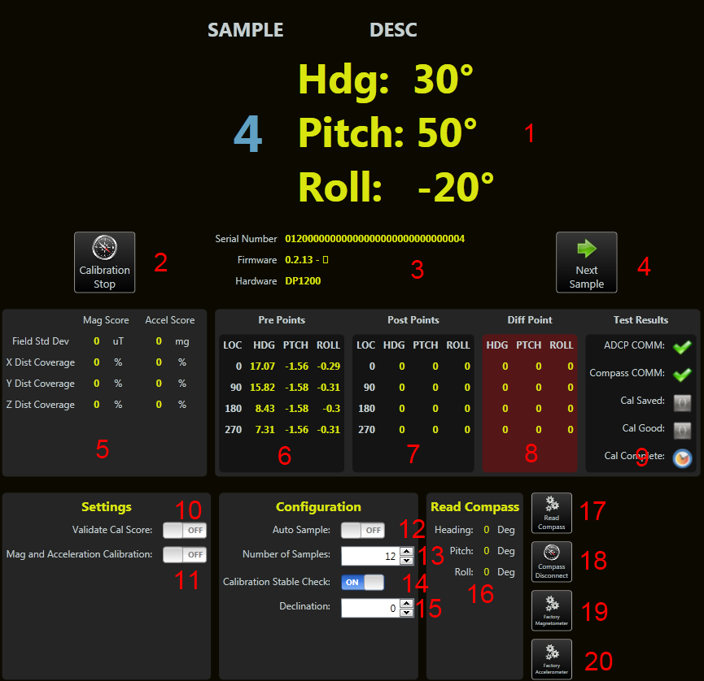

### 1. User Prompt

This is the location in the calibration where the user is given instruction in how to the place the ADCP for the next sample. At the very basic, a heading is given. For compass calibration, it will give a heading, pitch and roll.

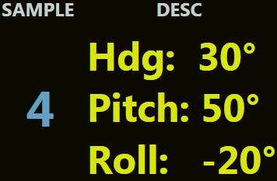

In this example, this is the 4th sample point. It is telling the user to have Beam 0 of the ADCP point to 30 degrees. Give a pitch of 50 degrees and a roll of -20 degrees. Once the ADCP is in this position, press the “Next Sample” button. When the compass reads this position, it will then move to the next sample.

### 2. Start/Stop Calibration Button

This button will allow the user to start or stop the compass calibration process.

**WARNING:**

**Stopping the Compass Calibration is very important to use if the calibration must be aborted. The ADCP is put in special mode and must be taken out of this mode for the ADCP to function properly.**

### 3. ADCP Info

This section give information about the ADCP. This will give the user feedback that an ADCP is found and that it is the proper ADCP to do the compass calibration to.

### 4. Next Sample Button

When performing the test, the user will need to tell the test when the ADCP is in the correct position to take a sample. The user will press this button when the ADCP is placed in the correct position. The compass will then take a sample and prompt from the next position.

### 5. Calibration Score

The magnetometer and accelerometer score are the score given by the compass. They are calculated based off the compass calibration. These scores are generated by the compass manufacturer. There are specs that the manufacturer has given for a good calibration also. The calibration score can also be used to determine if the calibration is good.

### 6. Pre-Points

These points are used to give a user feedback if the calibration was an improvement. When the pre points are collected, the user can see how far off the ADCP is in heading, pitch and roll. After the calibration, the post points are collected. Based off these points, you can see if an improvement was made or if the calibration made the heading worse. If the heading is more than 2 degrees off, then a calibration should be done again in a better environment. A good environment is one which is clear of magnetic material.

### 7. Post-Points

These points are used to give a user feedback if the calibration was an improvement. When the pre points are collected, the user can see how far off the ADCP is in heading, pitch and roll. After the calibration, the post points are collected. Based off these points, you can see if an improvement was made or if the calibration made the heading worse. If the heading is more than 2 degrees off, then a calibration should be done again in a better environment. A good environment is one which is clear of magnetic material.

### 8. Diff-Points

Diff points are the post points subtracted from the actual point. The difference is seen to verify if a calibration should be done again. Pitch and roll are subtracted by the pre and post points.

### 9. Test Results

This section is used to give the progress of the calibration process. It checks that a connection can be made to an ADCP. It then checks after the calibration that the calibration could be stored to the ADCP. It then verifies that the calibration was recorded to the maintenance file.

### 10. Validate Score Switch

This will use the Mag/Accel score to determine if the calibration was successful. This is for display purposes. The calibration will be still be performed and saved whether the scores pass or not. This will just give a warning to the user if the Cal scores fail.

### 11. Mag and Acceleration Calibration Switch

Perform both a magnetometer and accelerometer calibration. The accelerometer does not need to be calibrated for the ADCP to function properly.

### 12. Auto Sample Switch

Auto sample allows the user to perform the calibration without pressing the “Next Sample” button. When the compass feels the user has put the compass in a stable position, it will take a sample. The user can then move the compass to the next position and when it is stable it will take a sample. I have found when doing pitch and roll with the heading, the samples are taken before I am ready for the sample to be taken. When the calibration test begins, this options is turned off. It is then turned back on when the calibration is complete.

### 13. Number of Samples Input

The calibration allows between 12 and 24 samples to be taken for a calibration. The more samples taken, the better the result. The test works with only 12 samples.

### 14. Calibration Stable Check

When using Auto Sample, this will determine when the next sample should be taken. If this is turned off, then when the compass notices a stop, it will take a sample even if there is small movement going on.

### 15. Declination

If the user knows the correct declination for the location they are in, the user can set the declination for the compass.

### 16. Read Compass Section

To verify the compass is performing correctly, the “Read Compass” will allow the user to view the actual value seen by the compass. This makes direct communication to the compass to get a sample. To get a sample, press the “Read Compass” button.

### 17. Read Compass Button

This button will read a sample from the compass. This is used to verify the compass is performing correctly.

### 18. Compass Disconnect Button

If you abnormally stopped the calibration process, you will leave the ADCP in state where the compass will only output data. To put the ADCP back into a good state, you can press this button or the Stop Ping button on the serial port page.

### 19. Factory Magnetometer

Use the factory calibration for magnetometer. This is used when a good calibration cannot be accomplished.

### 20. Factory Accelerometer

Use the factory calibration for accelerometer. This is used when a good calibration cannot be accomplished.

# **Compass Utilities**

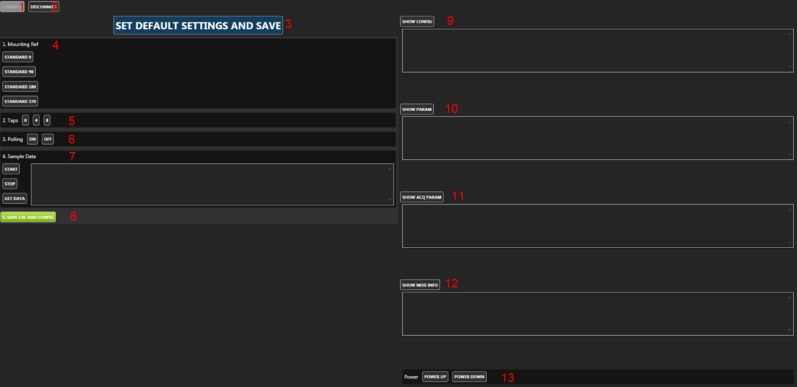

**WARNING:**

**To communicate with the ADCP compass, the ADCP must be put in a special mode. This mode will relay all commands to the compass. But the user must also remember to take the ADCP out of compass mode when they are done. If you leave this view, it will automatically disconnect from the compass.**

### 1. Connect Button

This button will connect the ADCP to compass mode.

### 2. Disconnect Button

This button will disconnect the ADCP from compass mode.

### 3. Set Default Settings And Save Button

This will set all the default compass values for the ADCP. This button is enabled only if the compass is connected. This button will do the equivalent of setting the mounting ref, taps, polling, sample data and hitting the save button.

### 4. Mounting Ref

This will set the mounting reference for the compass. This is the direction the compass will be pointed when moving forward.

### 5. Taps

This will set the taps for the compass. This has to do with filters and tables used for filtering.

### 6. Polling

This will set the polling on or off for the compass. When on, the user will need to ask the compass for a value. When off, the compass will output data automatically.

### 7. Sample Data

This will tell the compass to being outputting data continuously. Get Data will get a single sample.

### 8. Save Cal And Config Button

Once all the options have been sent to the compass, the configuration must be saved. This button will save all the configurations that are currently set in the compass.

### 9. Show Config

This will show the current configuration of the compass. This includes the declination, mounting reference and calibration settings.

### 10. Show Params

This will show the parameter of the compass. This includes the taps and the taps table.

### 11. Show Acq Param

This will show the acquisition parameters. This includes the polling mode.

### 12. Show Mod Info

This will show the compass’s firmware version and type.

### 13. Power

This will cause the compass to power down or up to save power.

# Compass Calibration Procedure

Below are instructions for performing both magnetometer and accelerometer user calibrations of the compass. These calibration sequences demonstrate a good distribution of the recommended minimum sample points: additional sample points may be taken.

Once calibration is complete the “Calibration Results” will indicate the quality of the calibration. This applies to both magnetometer and accelerometer calibration. The X, Y, and Z values show a percentage of each vector that has been covered during the calibration. For magnetometer calibration, a score of ≥85% is desirable for the X and Y vectors. The only way to get a Z value greater than 50% is to take calibration points with the unit upside-down as well as right-side-up. For accelerometer calibration, a score of ≥95% is desirable for the X and Y vectors, and ≥90% for Z vector. The values shown in μT for Mag Score and mg for Accel Score refer to the standard deviation of the measured samples when compared to the calculated values. The value for the Mag Score should be ≤0.1 and the value for the Accel Score should be ≤2.

At least 12 Calibration Points are required for the magnetometers to be calibrated, and at least 18 if the accelerometers or the accelerometers & magnetometers will be calibrated. The maximum number of calibration points allowable is 32, although generally the recommended number of calibration points is sufficient.

Select “Accel and Mag Calibration”, depending on which calibration procedure will be undertaken.

## 1. Magnetometer Procedure

• Hold the module level and stable.

• Click on the <Start Calibration> button and wait for a sample to be taken.

• Rotate the module to the next pattern position and hold the module stable until the next sample is taken.

• Repeat this until all samples, as set above, are taken.

• Click on the <Save Current User Cal> button

*Note: Once you begin taking calibration points, pausing between desired calibration points will cause unintentional points to be taken with auto sampling enabled.*

**Module approximately level**

• 0° yaw

• 90° yaw

• 180° yaw

• 270° yaw

**With module pitched positively ≥ 10 deg (recommended +50 degrees)**

• 30° yaw with small negative roll

• 120° yaw with small positive roll

• 210° yaw with small negative roll

• 300° yaw with small positive roll

**With the module pitched negatively ≥ -10 deg (recommended -50 degrees)**

• 60° yaw with small positive roll

• 150° yaw with small negative roll

• 240° yaw with small positive roll

• 330° yaw with small negative roll

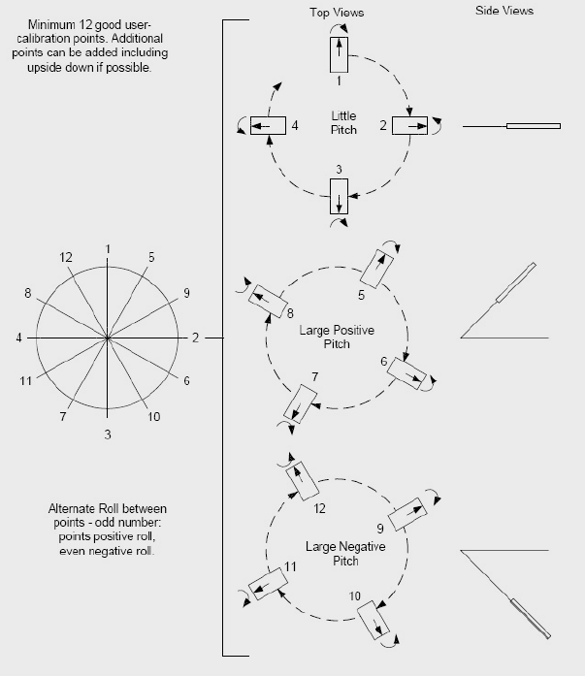

## 

## 2. Accelerometer Procedure

The requirements for a good accelerometer calibration differ from the requirements for a good magnetometer calibration. For instance, a level yaw sweep, no matter how many points are acquired, is effectively only 1 accelerometer calibration point. PNI recommends an 18 point (or more) full range calibration pattern for the accelerometer, as described below.

• Figure below shows the two basic starting positions for the accelerometer calibration. Calibration can occur within the user’s system or with the module alone. It is not necessary for the module to be placed on a hard surface as shown, but the gravitational vector (relative to the module) must be as shown. Also, the module must be held still during calibration, and holding it against a hard surface is one method to help ensure this.

• Using the module as shown on the left, rotate the module such that it sits on each of its 6 faces. Take a calibration point on each face.

• Using the module as shown on the left, rotate it 45° such that it is standing on one of its corners, as shown for the module on the right. The picture shows the module also rotated about its Z axis, but this is only for illustration purposes. Take a calibration point (0°). Now tilt the module back 45° and take another calibration point (+45°), then tilt the module forward 45° and take another calibration point (-45°). Repeat this 3-point process by holding the module on each of its 4 corners.

• Note that the 18 calibration points can be obtained in any order.

